

Our Family and Significant Others Services Strategy
2026-2027

Governor Diane Lewis
Date 01/02/2026

Family Strategy

Version  Date approved by  SMT | 1.0
Date published
Date for review | Jan 2026
Authored by | Emma Walton
Plan owner | Head of Reducing Reoffending – Jess Tile

Safer custody hotline
If you have concerns about the safety or wellbeing of a prisoner in Leeds, call the safer custody hotline. Leave your name, your telephone number, the prisoner’s name and prisoner number, and a brief description of the problem. Someone will call you back within 24 hours.
Telephone: 0113 203 2629
In an emergency, call the main switchboard on 0113 203 2600.
Online Safer Custody Form Portal - HMP Leeds | Prisoners' Families Helpline (prisonersfamilies.org)

Document change record

This change log is used to provide a trail of all approved changes made to this document. Changes are reviewed and approved prior to incorporation using established management procedures. Updated revisions of this document will be made as approved changes impact content or page numbers.
Version | Pages affected | Revision | Author
0.1 | All | First draft | Emma Walton
1.0 | All | Published | Emma Walton

Foreword

Strong, supportive relationships play a vital role in a person’s wellbeing, stability and progress through custody. At HMP Leeds, we recognise that maintaining family and significant-other connections is not only central to rehabilitation but also key to reducing intergenerational harm and improving long-term outcomes on release. We therefore have a responsibility to support these relationships wherever it is safe, appropriate and in the best interests of all involved.

This strategy sets out how we will continue to strengthen our offer for families, children and significant others, working closely with Jigsaw, our community partners and the wider Reducing Reoffending team. It reflects our commitment to inclusive practice, early support during the first days in custody, and improved provision for those with no existing contact. It also outlines how we listen to the voices of prisoners and visitors, and how this feedback shapes our future direction.

We know that imprisonment impacts families too, often in ways that are unseen. Our aim is to create a safe, respectful and welcoming environment where families feel informed, valued and supported throughout their journey.

By working together, staff, partners, prisoners, families and the community, we can strengthen relationships, reduce risks, and help build positive futures beyond custody.

Diane Lewis
Governing Governor
HMP Leeds

Document contents
Family Strategy 2
Safer custody hotline 2
Document change record 3
Foreword 4
Document contents 5
1. Purpose and Scope 6
2. Introduction 8
3. Diversity and Inclusion 9
4. Understanding Needs 10
5. Performance and Assurance 11
6. Facilities 14
7. What we offer 17
8. Safeguarding 23
Annex 25

Purpose and Scope

This strategy has been written in consultation with Jigsaw, our Family Contract provider. We work closely with Jigsaw to provide a quality service which aims at making a difference. The current contract commenced in October 2022 and will run for 5 years.

Purpose

The purpose of this strategy is to provide staff, prisoners, prisoner families and significant others with an overview of what HMP Leeds currently provides and our hopes for the future. We are very aware that a strong and supportive family network can ultimately encourage a reduction in re-offending by building resilience and improving family dynamics. Our aim is to increase the amount and quality of interactions between prisoners and their families where appropriate. We recognise that families can take many different forms for individuals including:

- Nuclear families
- Adoptive families
- Single parent families
- Extended families
- Childless families
- Stepfamilies (blended families)
- Grandparent families

For the purpose of this strategy, we refer to a significant other being a spouse, or a person who has a great influence in an individual’s life.

Scope

- Working to maintain and improve contact with Family and Significant Others.
- Activity provision in visits
- Services for visitors
- Provision for individuals who have no contact with Family and Significant Others.
- Family engagement and advice
- Governance
- HMIP Expectations

Out of Scope

- Visits policy
- Security policy
- Public protection policy

Aims of this strategy

This strategy, along with the governance arrangements that help make sure our action plan is delivered, aims to:

- Reduce the risk of reoffending by helping prisoners to maintain and strengthen relationships with family and significant others, through contact while in prison
- Help prisoners to maintain contact with their children and families and to help prisoners be good role models despite being in prison, helping to reduce the risk of intergenerational offending
- Help partners, parents and families who also need support, acknowledging the hidden sentence they are serving
- Improve awareness of the support available to prisoners and their families
- Acknowledge the unique needs of our population, particularly foreign national prisoners, those serving a sentence far from home and those who are care experienced
- Show prisoners, families and significant others what we offer, to hold ourselves to account for delivering it well, and seek feedback from prisoners and families about what we could do better.
- To identify improvements to our service through seeking feedback, good practice and improved partnership working with our partners, evidenced through more consistent governance arrangements.

Introduction

The Farmer report, ‘The Importance of Strengthening Prisoners Family Ties to Prevent Re-offending and Reduce Intergenerational Crime’ was published in 2017. The report recommended family should be the “golden thread” running through all prison processes.

This strategy is developed with recognition of the importance for Family and Significant other services in Custody.

Oversight and Governance

The Family and Significant Others provision is overseen by the Head of Reducing Reoffending, Jess Tile. They are the strategic owner of the Family and Significant Others pathway, with responsibility for its governance, oversight, and effective implementation across the establishment, with support from:

- Family and Significant Others Champion - Custodial Manager E Walton - The Custodial Manager is responsible for the day-to-day management of the Family Services pathway. They develop and maintain the strategy, oversee quality assurance, and ensure that delivery meets required standards.
- Family and Significant Others Officer – Officer C Gallagher - The Officer provides operational support to implement the Family and Significant Others work. They assist with the daily running of services and support the Custodial Manager to ensure consistent and effective delivery.
- Reducing Reoffending Officer – Officer A Taylor
- Jigsaw Contract Management team
- Jigsaw family team
- Jigsaw visits team
- DARS (Drug and Alcohol Recovery Service) Family Lead
- Gym Instructors
- Offender Management team
- Chaplaincy team
- Q-Branch
- Shannon Trust
- Novus Education provider

HMP Leeds holds quarterly meetings with the contract provider Jigsaw to ensure that the contract is being adhered to. We also hold quarterly performance review meetings where any issues are escalated to the regional contract manager.

Diversity and Inclusion

We have signed up to the HMPPS Diversity and Inclusion Statement and are working toward making sure that we deliver this commitment: “HMPPS is committed to Diversity and Inclusion for all. We treat our staff with respect and ensure equality of opportunity. We deliver our services fairly and respond to individual needs. We insist on respectful and decent behaviour from staff, prisoners, children, people on probation, and others with whom we work. We do not tolerate discrimination, harassment or bullying and we take prompt and appropriate action whenever we discover them. This is underpinned by our adherence to the Public Sector Equalities Duties as outlined in the Equality Act 2010.”

HMPPS are required to follow and abide by relevant equality legislation including the Equality Act 2010 and the Public Sector Equality Duty and Gender Recognition Act 2004.

The Equality Act 2010 legally protects people from discrimination.

There are nine protected characteristics defined under the Equality Act. These are:

- Age
- Disability
- Gender reassignment
- Marriage and Civil Partnership
- Pregnancy and Maternity
- Race
- Religion and Belief
- Sex
- Sexual Orientation

We have strand leads for each protected characteristic and will continue to work with them to ensure that prisoners’ families and significant others are treated fairly and without prejudice. We will promote an inclusive environment during visits, our family days and enrichment activities. You will be able to find the names of strand leads within the visiting hall and on residential units.

Understanding Needs

Needs Analysis

We aim to be innovative and respond to the changing needs of the population at HMP Leeds by conducting an annual self-assessment as part of the Family performance measure. This involves providing evidence that we have an appropriate visitors’ centre, a visits hall which is an inclusive environment, encouraging positive relationships with Family and Significant Others, and encouraging family involvement in aspects of prisoners’ journey through custody.

To meet these measures, we constantly review the needs of individuals through our monthly Family and Significant Others’ meeting. During this meeting we discuss feedback received from various forums and agencies and include this in our action plan (annex). Through feedback from staff, prisoners, and their families and significant others, we aim to make the journey through custody more productive, accessible and supportive.

Visitors’ Voice

Visitors’ Voice is a feedback session run by Jigsaw Quarterly with support of HMP Leeds staff allowing prisoners’ families and significant others to give positive and negative feedback with the overall aim of improving our provision and support.

Feedback from Visitors’ Voice is discussed at family Governance meetings where issues can be addressed, added to the action plan (Annex) and positive feedback be cascaded.

We also value feedback from children and the Jigsaw staff will gather any feedback when appropriate with parent/guardian’s consent.

Prisoners’ Voice

We hold monthly residential consultative meetings on each wing where prisoners are given the opportunity to give feedback to staff including positives, negatives and suggestions of how we can improve. Within this meeting, Family and Significant Others provision is discussed and feedback given to the reducing reoffending team and added to the Family and Significant Others action plan and approach.

The Governor and Deputy Governor also hold a monthly Prisoner Council with prisoner representatives from all wings and all prison departments represented by their Head of Function. These meetings are minuted and aim to address concerns as well as generate ideas. It is also used as a forum to test or seek ideas when change is needed.

5. Performance and Assurance

There are various ways in which we are measured with regards to the services we provide for prisoners and their families or significant others. This includes those listed below.

Yearly Self-Assessment

The Family Measure is a recognised national performance measure implemented by the Prison Service which makes up part of the overall performance of individual prisons.

“Establishments will need to complete a self-assessment measure, answering a range of questions covering Family and Significant Others work. The measure is designed to encourage a proactive approach to Family and Significant Others work, and an establishment will score well if it is able to evidence proactivity in response to the range of questions within the measure.”

The recent self-assessment was completed in April 2025 and an action plan which is reviewed quarterly was updated. The actions are monitored via the quarterly Family and Significant Others meeting where each function is represented.

Monthly updates are given by the Head of Reducing Reoffending during the Senior Management Team’s (SMT) Performance meeting.

HMIP

All HM Prisons are subject to inspections by HM Inspectorate of Prisons. HMP Leeds last HMIP visit was in July 2025. The following was found:

- Priority concerns 1. Support for new arrivals was not good enough. Too many were unable to telephone their family and waited too long for their first visit. Prisoners were not informed of what to expect during their early days.
- 3.4 Too many prisoners were unable to make a telephone call to their family or friends on arrival. In our survey, just 36% said they received a Report on an unannounced inspection of HMP Leeds 13 free phone call before they were locked up on their first night. Among those charged with a sexual offence, the finding was even worse. Prisoners subject to public protection restrictions could not make phone calls themselves until telephone numbers had been approved. In the meantime, staff usually offered to make a call to a family member on their behalf, but the prisoner was not permitted to be present during the call, which was more restrictive than we usually see. Other prisoners, who were not subject to these restrictions, were given a £1 phone credit. However, the prison sometimes ran out of these credit slips so not all new arrivals had the opportunity to call their family on their first night. Furthermore, staff sometimes inaccurately recorded that they had been issued the phone credit, which led to disputes the following day.
- 3.7 New arrivals usually had to wait around 10 days before receiving their first visit from family or friends, which was too long.
- 6.1 There was far too little family engagement work for the substantial number of men passing through the prison. Jigsaw, the longstanding provider, delivered a very good service to visitors, but was only contracted to provide one part-time caseworker to help prisoners rebuild family ties. There were no parenting courses.
- 6.2 The introduction of a families and significant others (FASO) officer was positive, but she was frequently redeployed to other duties. The schools project that the FASO ran was excellent, allowing teachers from local schools to visit the prison and see what pupils with a father held at Leeds were experiencing. She also ran monthly events for prisoners who did not receive visits or phone calls, although these had been cancelled frequently.
- 6.3 There were excellent and reliable opportunities for school-aged children to have early evening visits with their fathers which we rarely see in a busy men’s reception prison. There was also a good range of family sessions and themed events every Friday morning across the year.
- 6.4 Social visits were constantly at full capacity. Most families were from the local area and keen to attend in person, but the visits hall was much too small for a mostly remanded population who needed and were entitled to more visits. There were almost 800 unsentenced men in the prison but only 380 face-to-face visit slots each week. Consequently, new arrivals typically waited up to 10 days for their first visit, which was much too long (see paragraph 3.7). It was also too difficult to book a visit on the phone, not least because the two visits booking clerks had been working for over a year in an office which had only one phone line to receive calls
- 6.5 About 300 emails were printed off and distributed to prisoners each day through the eMates scheme. More than half the population had public protection markers. Those prisoners sometimes had to wait longer for their phone numbers to be added to their account because offender management unit public protection clerks were not sufficiently resourced to contact family members for approval for contact.
- 6.9 There was still not enough support for remanded prisoners. They were now included in more contracted work, for example they could be referred to a housing worker, but we did not find enough evidence of reliable support for this majority group of prisoners. Even when referrals had been completed, they did not receive regular communications to allay their concerns. Remanded men also lacked the levels of contact we would expect from key workers, family engagement workers and chaplains (see paragraphs 4.3, 6.1 and 4.31).

Independent Monitoring Board

The Reducing Reoffending Team work closely with the Independent Monitoring Board (IMB) who are a team of volunteers appointed by the Secretary of State.
Their role is to monitor the conditions in which prisoners are held and their treatment. The IMB are obliged to write an Annual Report which goes to the Minister for Justice and is published for everyone to see.

Any concerns raised are addressed in a timely manner and, although rare, any trends will be recorded and discussed within the monthly Reducing Reoffending governance meetings.

Audits

Jigsaw conduct their own internal audits and findings are discussed within the governance meetings.

It is seen as good practice to conduct peer audits to provide assurance. Due to good relationships with other prisons we have the capability for these to be carried out. Our last peer audit was conducted in October 2023 by Head of Reducing Reoffending, HMP Kirklevington Grange.

Assurance visits are also conducted by the regional team who report to the regional Prison Group Director.

Action plan

After gathering feedback from various sources and analysing this we have created an action plan which is continuously being updated, with the aim of being innovative in assisting and improving contact with Family and Significant Others. This action plan is discussed at the quarterly Family and Significant Others meetings. A summary of some of the main actions are included at the back of this document (Annex).

6. Facilities

Jigsaw Centre

The Visitors Jigsaw centre is open at visits times to welcome and support visitors providing;

- Café with hot and cold refreshments
- Toilets with disability access and baby changing facilities
- Disabled parking
- Inside play facilities
- Jigsaw staff on hand to support and answer questions

Our visitor’s centre is staffed by trained Jigsaw Family Support Workers who are on hand for advice and support, explaining the visits process in a child friendly manner. The centre has recently undergone some updates to make the environment more welcoming and accessible.

Support for Families of Prisoners
Jigsaw can help you with the impact of imprisonment on you and your family. They can support you through any practical issues you may have, including housing, health, finances, drugs and alcohol, and can also offer you access to counselling. If you would like to talk to someone about this support, contact Jigsaw and ask to speak to our Family Support Workers.

Visits Hall

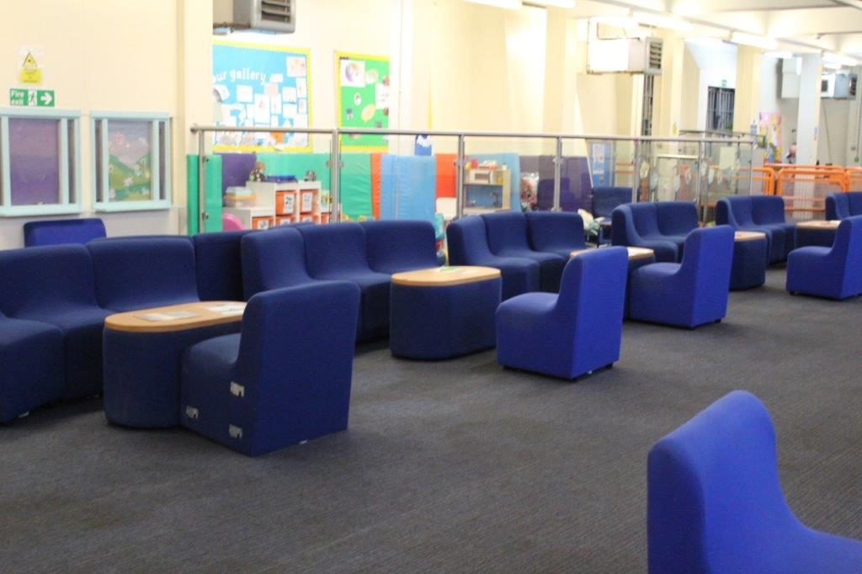
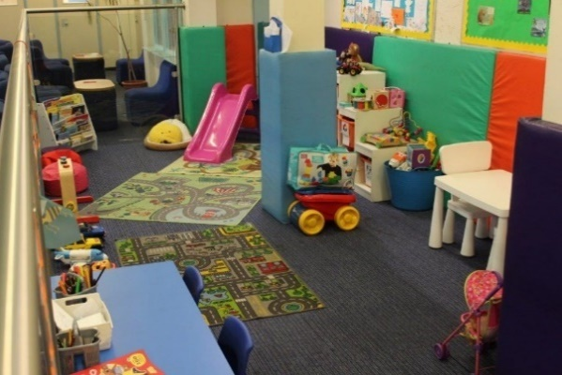

The visits hall at HMP Leeds includes:
- Café serving hot and cold drinks and snacks
- Play facilities open weekends and School Holidays with support from qualified Jigsaw Family Workers.
- Visits hall is part of the Breast-feeding Friendly scheme
- Gender neutral disability compliant toilet
- Baby change provision

Q-Gardens
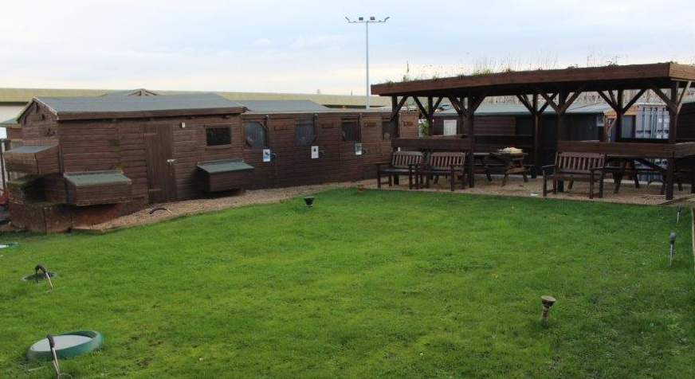
Q-Gardens is an enterprise run by prison staff and prisoners. This area is used for some of our family days. It includes:

- Outdoor seating
- Grass area for children to play.
- Aviaries housing various birds including owls and kestrels.
- Free range chickens
- Ferrets
- Poly tunnels where fruit and vegetables are grown.
- Hand built pizza oven
- Purpose built kitchen for pizza and BBQ food preparation.

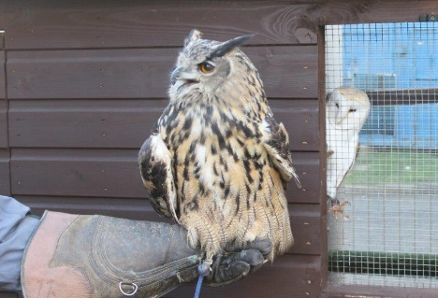

7. What we offer

Visits

All our visiting and contact arrangements are provided to visitors in an information booklet for families updated and maintained by our Jigsaw family support service. This is also maintained on the Prison website and provided to prisoners. This forms part of the induction programme which is offered to all prisoners on reception to HMP Leeds.

As a prison we prioritise staff and resources to ensure our visits timetable and mail system is delivered giving confidence and assurance to prisoners and their families. We aim to ensure all families and visitors feel they are treated with decency and respect and their interaction with the Prison and staff is positive.

Social Visits are available Monday-Wednesday afternoon and evening. Friday afternoon. Saturday and Sunday morning and afternoon. No social visits take place on a Thursday.

Visits are arranged by the ‘visits booking’ process. We regularly test these arrangements and monitor their effectiveness.

Visits can be booked in a number of ways:

By phone: 0113 2032570 Monday - Friday (excluding bank holidays)
08:30 to 09:30 and 13:00 to 14:00

By the internet:
www.gov.uk/prison-visits

In person:
Bookings can also be made in person at the prison every day in the Prison gate (excluding bank holidays) 08:30-12:30

Digital Services

Legal Visits
Following the review of Legal visits at HMP Leeds a new way of conducting visits was introduced. This was in the form of a “cloud platform”. Legal visits are mostly accommodated over the cloud platform. However, we have recognised the need for some face-to-face legal visits to take place. These are now facilitated in our VCC which allows for a private, professional space.

Email a prisoner
Family and friends can send e-mails to prisoners using the email a prisoner service. It will take approximately 24 hours for emails to prisoners to be printed and issued to a prisoner and a similar length of time to scan their letter to email to you.
www.emailaprisoner.com

Prisoner Voicemail
Family and friends can leave voicemails for prisoners to listen to and reply to using the PIN phones using www.prisonvoicemail.com.

In Cell telephony
All prisoner cells are now equipped with in cell phones for use with a prisoner’s pin phone number. These are for outgoing calls only. For safety, security, and victim protection, 3-way calls are not allowed and are against prison rules.

Virtual Visits
Previously called ‘Purple Visits’, the Virtual Visits system allows for prisoners to see loved ones virtually over a half hour virtual call. This facility allows prisoners to see family and friends who may find attending physical visits harder due to distance etc.

A - E Wing - Monday and Tuesday only
F Wing - Wednesday only
14:30, 15:30, 16:30, 17:30, 18:30

Family Days

In addition to social visits, we hold regular family visit days as extended visits when advertised, prisoners can apply, and places are granted following a risk assessment to ensure safety of all.

We also hold regular family fun days as part of engaging with the DARS team on the Incentivised Substance Free Living wing (A-wing).

Enrichment Activities

Activity packs for Virtual Visits
Following the introduction of virtual visits, Jigsaw looked at ways to enhance the experience for the prisoners and their family on the virtual visit. They designed and introduced age-appropriate activity worksheets and activity pack for each wing for the Prisoners to use on their video calls with their children.

Storybook Dads
Jigsaw offer the Storybook Dads service that enables families to reconnect through the magic of storytelling. We help prisoners to record bedtime stories and messages for their children on to a DVD. For many families, these story discs are a lifeline, helping to heal rifts and build vital family relationships. It shows the children they are loved and missed. It helps prisoners to feel valued as parents and gives them the opportunity to have a positive impact on their children’s lives. Prisoners are able to apply via application through the Prisoner Information Desk on each wing.

Parent and tots’ visits
Parent and tots’ visits are two-hour visits which take place throughout the year on Friday mornings. Jigsaw staff organise a family activity and toys will be available for you to play with together as a family, allowing dads to bond and play with their children.

Drug and Alcohol Recovery Services (DARS) family learning
DARS are committed to encouraging education and training around drugs. They provide family packs, naloxone for families, link in with Storybook Dads, provide literature for the visits centre and attend family engagement events.

Family Support and Advice

Jigsaw
The Jigsaw team operate a family support line and face-to-face support service which is published for prisoners’ friends and family to contact for any additional support. They can support in the following areas:

- Supporting prisoners to re-establish positive contact with Family and Significant Others.
- Feed back to the establishment on any barriers to visits e.g. family contact/custody issues, neurodiversity needs, disabilities.

Jigsaw’s Family Support Workers are here to help and support prisoners through one-to-one case work with any issues such as:
​​
- Re-establishing contact with children and other family members
- Maintaining family ties
- Support with social services

Early Days in Custody support: The newly introduced Family Engagement Worker will be based on E Wing 3 days a week from February. Having the opportunity to engage with all prisoners within the first few days of arriving in HMP Leeds and to help solve any issues they have with family contact, make welfare calls, and help with any family matters that arise when coming into custody. This addition to the induction process will help to reduce frustrations and help all areas of the establishment including safer custody and FaSO ensuring all areas are informed and included where appropriate.

Inside Out Project: Jigsaw are now leading on the Inside Out Project. This is a community project in which staff from local schools and organisations are trained to help support children with loved ones in custody. As part of the project, Jigsaw have also employed 2 outreach workers who will work with families to support with any issues of loved ones in custody.

Beyond the family services provision HMP Leeds will work to ensure our staff and organisations working in the prison provide support to men around their family and relationships whilst in custody. We aim to ensure this is an integral part of service provision and will be an ongoing development as part of this strategy aiming to ensure family is ‘the golden thread’ throughout custody.

Prison Key Worker
Key Worker staff must prioritise family and significant-other support for prisoners in Early Days in Custody. At HMP Leeds we complete a face to face, family-focused session, within 14 days of reception in custody, and for individuals identified through the Safety intervention meeting as high-risk, ensuring attention to stability, communication, and any relationship-linked safety concerns. All interactions must be accurately documented using the CRISSA model (Check in, Review, Intervention, Summarise, Set and agree tasks, and Anti-discriminatory). CRISSA ensures structured, consistent, risk-aware, and outcome-focused discussions that support family ties and meet assurance and HMIP standards. Training and refresher opportunities are provided, and staff are expected to follow guidance and raise any safeguarding or process concerns through management, or the FaSO structure.

Chaplaincy
The chaplaincy team run a counselling service at HMP Leeds to support any prisoners who are struggling. Prisoners can be referred via wing staff, Healthcare, Probation or Offender Managers. There are currently 6 counsellors who have a case load of 2/3 prisoners each per week offering an initial 6 sessions with an extra 4 being offered in exceptional circumstances where required. Bereavement specific support is run by Cruse volunteers through Chaplaincy.

Angel Tree
Angel Tree is a very simple and incredibly rewarding way to help parents in prison stay in contact with their families during imprisonment. Angel Tree is run through chaplaincy every year. They organise Christmas presents and Easter for children of serving prisoners at no cost to the prisoner or their family. Last year they provided 180 children of 100 prisoners with presents.

Prisoners who do not receive visits

We are constantly reviewing and improving our offer for those who do not have contact with Family and Significant Others. Our Family and Significant Others Officer monitors this data closely and identifies individuals to offer them support. We run a dedicated visits session for these individuals where external agencies and stakeholders visit, mirroring a regular visits session, to offer support.

Official Prison Visitors
Official Prison Visitors (OPVs) are volunteers. They have a unique role offering to befriend a prisoner during their time in custody. The decision to be visited by an OPV is made by the prisoner. OPVs are non-judgemental, impartial, and they have no hidden agenda. Their visits may best be described, primarily, as 'visiting the person, not the prisoner' and to support this, OPVs know nothing more than the prisoner's name, number, and location on a first visit.

No Contact visits
A new initiative this year, run by the Family and Significant Others Officer. During these visits, those prisoners identified as having no contact with family or significant others by way of visits, phone calls or letters are offered the opportunity to attend a support visit with various agencies whom we work with and can socialise with other prisoners with similar circumstances in an atmosphere intended to feel like social visits.

Family and Significant Others peer reps
Another new initiative for this year, overseen by the Family and Significant Others Officer are the peer workers who are available during domestic periods on each wing to signpost and offer support to any individual who does not receive any contact, or may be struggling with negative relationships. These reps are identified as the most suitable candidates and they are provided training from the FaSO Officer, with regular check ins to ensure compliance and confidence.

Reading Opportunities

HMP Reads
HMP Leeds was the first prison to develop a comprehensive strategy to raise the reading standards of prisoners here and encourage more reading for pleasure. This followed the 2022 review of reading education in prisons by HM Chief Inspector of Prisons, Charlie Taylor.

The Shannon Trust
Over 60% of people in prison struggle with reading and writing. Some cannot read at all. Around two thirds of people in prison also struggle with basic numeracy skills. Learning to read, write and do numeracy transforms lives and can be a powerful springboard into so many other opportunities.
This learning allows those in prison access to more opportunities, can improve their confidence and independence. The Shannon Trust uses peer support to allow both mentors and learners to develop key skills that can help them find future employment. This also creates a less daunting learning environment for those who may have had bad past experiences with learning.

Children’s Book Project
Working in partnership with The Children’s Book Project, we introduced the book hut to the visits hall. It aims to provide bonding opportunities for families to read together during visits. Children can take books home with them to encourage reading at home and prisoners can take the same book back to their cell to read together over the phone.

Popup bookshops are held seasonally to give prisoners the opportunity to choose books to send as gifts to their children, grandchildren, nieces, nephews or siblings.

Heading Home

Offending Behaviour Courses
Prisoners may be directed by their Prison Offender Manager (POM), or the Secretary of State to participate in specific offending behaviour courses to meet their needs. These programmes are not run at HMP Leeds due to being a reception prison and so these courses will be accessed in other prisoners after prisoners are sentenced and categorised.

Care Experienced
HMP Leeds is committed to ensuring that individuals who are care experienced are correctly identified and given the support and pathways required to enable them to succeed whilst in custody and on release. This information is gathered on reception and during the early days in custody screening. Support is signposted at that point and throughout the custodial journey. Our support is measured as part of the yearly self-assessment. We are currently working on ideas linked to care experienced individuals to offer a better level of support.

Foreign National Prisoners
We support foreign national prisoners on a case-by-case basis. This is dependent on the level of contact they have with Family and Significant Others within the UK. In cell telephony allows calls to be made at any time of day which can help prisoners having to contact family in a country with a different time zone. We work closely with the Foreign National Officer, Chaplaincy, and the Home Office to ensure we are aware of Foreign national prisoners and support them the best we can.

Employment
Our Prison Employment Lead heads a team of partners who offer support and guidance around employment on release. There is an ongoing process our prison runs to capture needs of those requiring this support. Our work readiness assessments include information around family life at home. The ongoing work to help prisoners be job ready (have a Curriculum Vitae, bank account and photographic identification) and plan job interviews, allows prisoners to financially support their families, especially those with young children, on release by gaining employment.

8. Safeguarding

Safer Custody Hotline

Contact arrangements for concerned families and others:

Friends / Family members who have concerns regarding safety of a prisoner within HMP Leeds can contact the Safer Custody Team on 0113 2032629.

This is an answerphone service where concerns can be left, the answer phone is checked numerous times throughout the day. Staff will return calls within office hours Mon – Fri.

Outside of these hours and in an emergency, concerns can be raised via the main prison number on 0113 203 6000.

These arrangements are widely published including in visits areas, visits centre and in the establishment generally.

Online Safer Custody Form Portal

The online form portal allows families and significant others to submit the relevant forms if they are concerned about issues such as Healthcare, Bullying and Violence, Emotional Support, Prisoner contact, Transfer and Release, Finances, Visiting, Property and Clothing, and Urgent numbers.

HMP Leeds | Prisoners' Families Helpline (prisonersfamilies.org)

If the concerns do not relate to any of the above issues, families and significant others can contact the Prisoners Families Helpline.

The Prisoners Families Helpline

If you have ongoing concerns, general worries and/or questions:

If families or significant others have a general worry about a prisoner and have questions about their care in custody, what they might be entitled to or are worried their concerns are not being responded to they can call free, on 0808 808 2003. Trained advisors can offer information, advice and support. The line is open 9am – 8pm Monday to Friday and 10am – 3pm at the weekend.

Safeguarding Lead

Our Adult Safeguarding Lead at HMP Leeds is Kelly Franks, Head of Drug Strategy. She is in charge of the local policies and procedures relating to Adult Safeguarding which can be found in the Safeguarding Strategy and relevant communications throughout the establishment.

Our Child Safeguarding Leads are Heidi Seavers and Dee Celebicanin.

Annex

Family and Significant Others Action plan

We have updated our action plan to make sure we keep providing better support for prisoners and their families. The following priorities summarise the action plan.

Priority 1
Improving our offer for those without contact: In the last year we have again improved our knowledge as an establishment of those who do not have contact with family or significant others through the work of the Family and Significant Others Officer and others within Reducing Reoffending function. In the last year we have introduced a variety of support mechanisms, and we aim to increase the offer again in the next year. We are in the process of rolling out:

- Care leaver or care experienced representative on each wing to support all prisoners who have spent time in the care system.
- A specific visits session aimed at care experienced individuals, which will be similar to the current visits for those with no contact, inviting along their PAs where appropriate.
- Continue with dedicated visits for those without any contact. During these visits, those prisoners identified as having no contact with family or significant others by way of visits, phone calls or letters are offered the opportunity to attend a support visit with various agencies whom we work with and can socialise with other prisoners with similar circumstances in an atmosphere intended to feel like social visits.

Priority 2
Improving our offer for early days in custody prisoners: We aim to be more supportive of those particularly within their first 7 days in custody and those on recall to ensure they are receiving eh appropriate help as a priority. Jigsaw have recently employed a Family Engagement Worker who is dedicated to the Early Days in Custody unit and works closely with the staff on E wing, the Families and Significant Other’s Officer and Reception staff to signpost, refer and offer individual support based on needs. In the next year we aim to consider:

- Introducing a dedicated visits session for individuals during their early days in custody to ensure they maintain positive relationships and gain support from outside of the establishment.

Priority 3
Being more innovative and inclusive: Although our visits and family provision has scored well on HMIP inspections we are constantly reviewing feedback from visitors and prisoners. In doing this we aim to be more innovative in the things we offer and in turn be even more inclusive. We have trialled various initiative such as “quiet time” visits for those with neurodiverse needs. However, the uptake was low and as such impacted on the visits offering for the wider population. We aim to:

- Constantly review feedback from prisoners and their visitors and trial any appropriate suggestions to offer a better, more inclusive visiting environment for all

