



HMP Moorland
Family Strategy

January 2026

We are committed to working with our partner agencies to deliver effective family services, which support those in our care and their loved ones in the community. | 
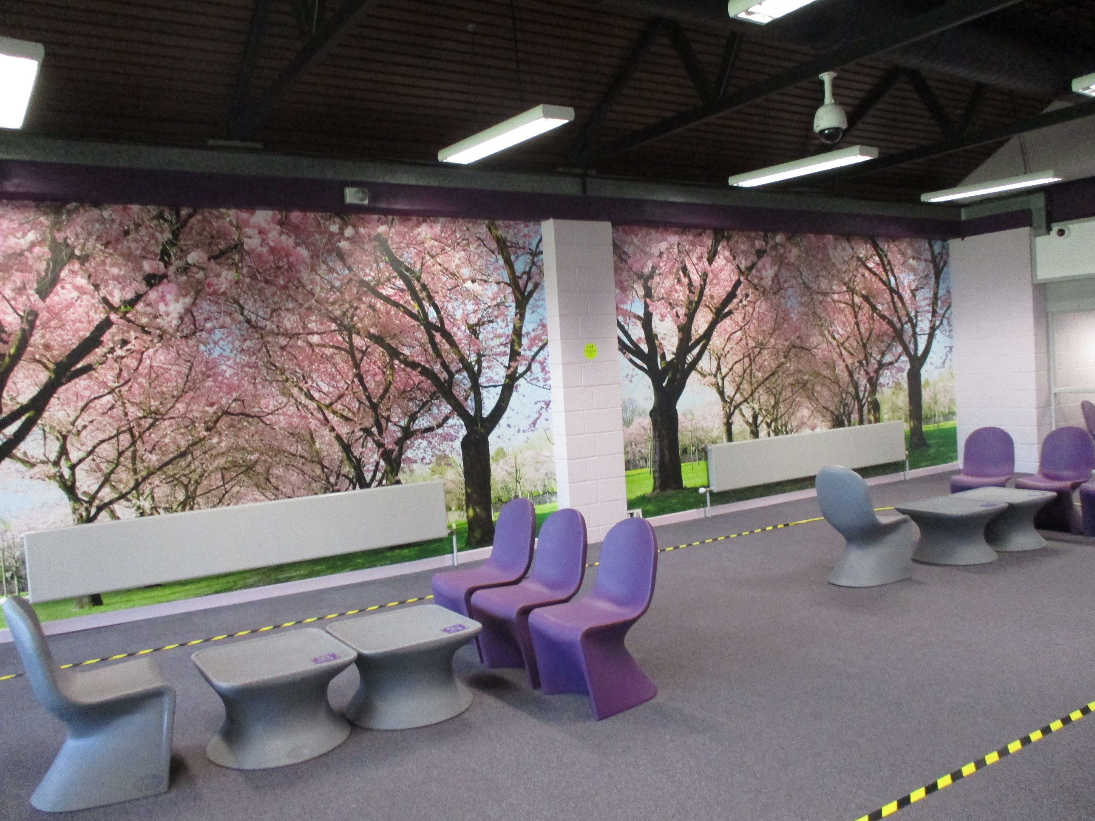 | 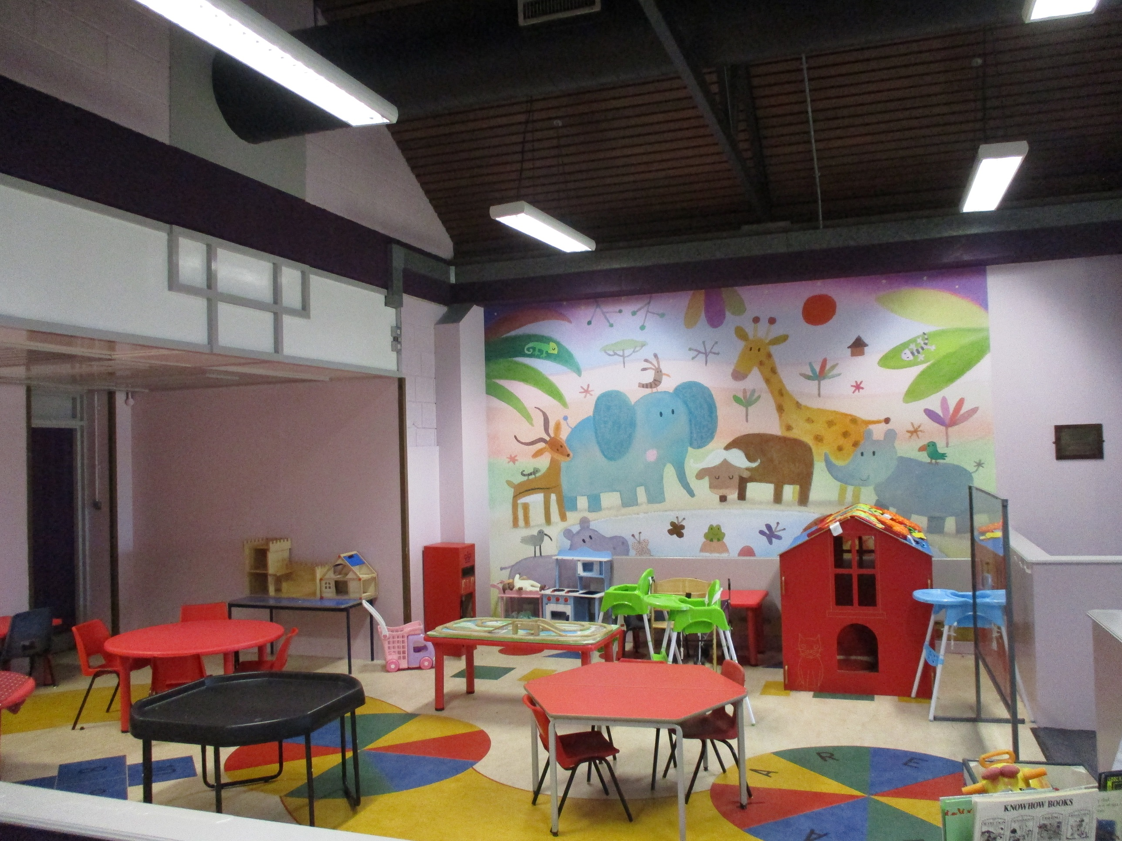

It is widely recognised that supporting those in custody to develop meaningful and constructive relationships with family and significant others, can help to build safer and calmer custodial environments, support a reduction in reoffending and help to minimise the negative impacts, a custodial sentence can have on the wider family.
Those in our care do not always have family, however we understand the importance of all external support networks, which can provide our men with emotional support.
“I do want to hammer home a very simple principle of reform that needs to be a golden thread running through the prison system and the agencies that surround it.

That principle is that relationships are fundamentally important if people are to change.“
Lord Farmer review 2017

Introduction
At HMP YOI Moorland we all have a responsibility to help maintain positive relationships.

Supporting a person in our care to develop meaningful and constructive relationships with their family or significant others is vitally important, especially considering the distance some families may have to travel to visit their loved ones.

At HMP YOI Moorland we want to make visits less daunting, more child friendly and stimulating for all that attend whilst adhering to all security procedures.

HMP YOI Moorland is committed to developing new ideas and supporting those who do not have visits to help build or repair relationships or to gain support during and after release.

For the purpose of this document, ‘Family’ is defined as either a relative or significant people that a person in our care identifies as providing a constructive and supportive relationship.

History
HMP YOI Moorland is a male Category C prison on the outskirts of the city of Doncaster, South Yorkshire. It is operated by Her Majesty’s Prison Service. It opened in 1991 and houses a mixed population of category C people, including those sentenced to short terms who are resettled in to the Yorkshire area, long term people convicted of sexual offences, young adults and foreign national prisoners. This includes a number of individuals serving Indeterminate Public Protection (IPP) sentences

Visits
Visits are available four afternoons per week and need to be booked in advance. You can do this online at www.gov.uk/prison-visits or using the telephone booking line 01302 523289.  Our clearly signed Visitors Centre is open for an hour before visits start and is staffed by friendly and welcoming Prison / PACT Staff, who can advise on any issues around visiting, particularly for first time visitors. | 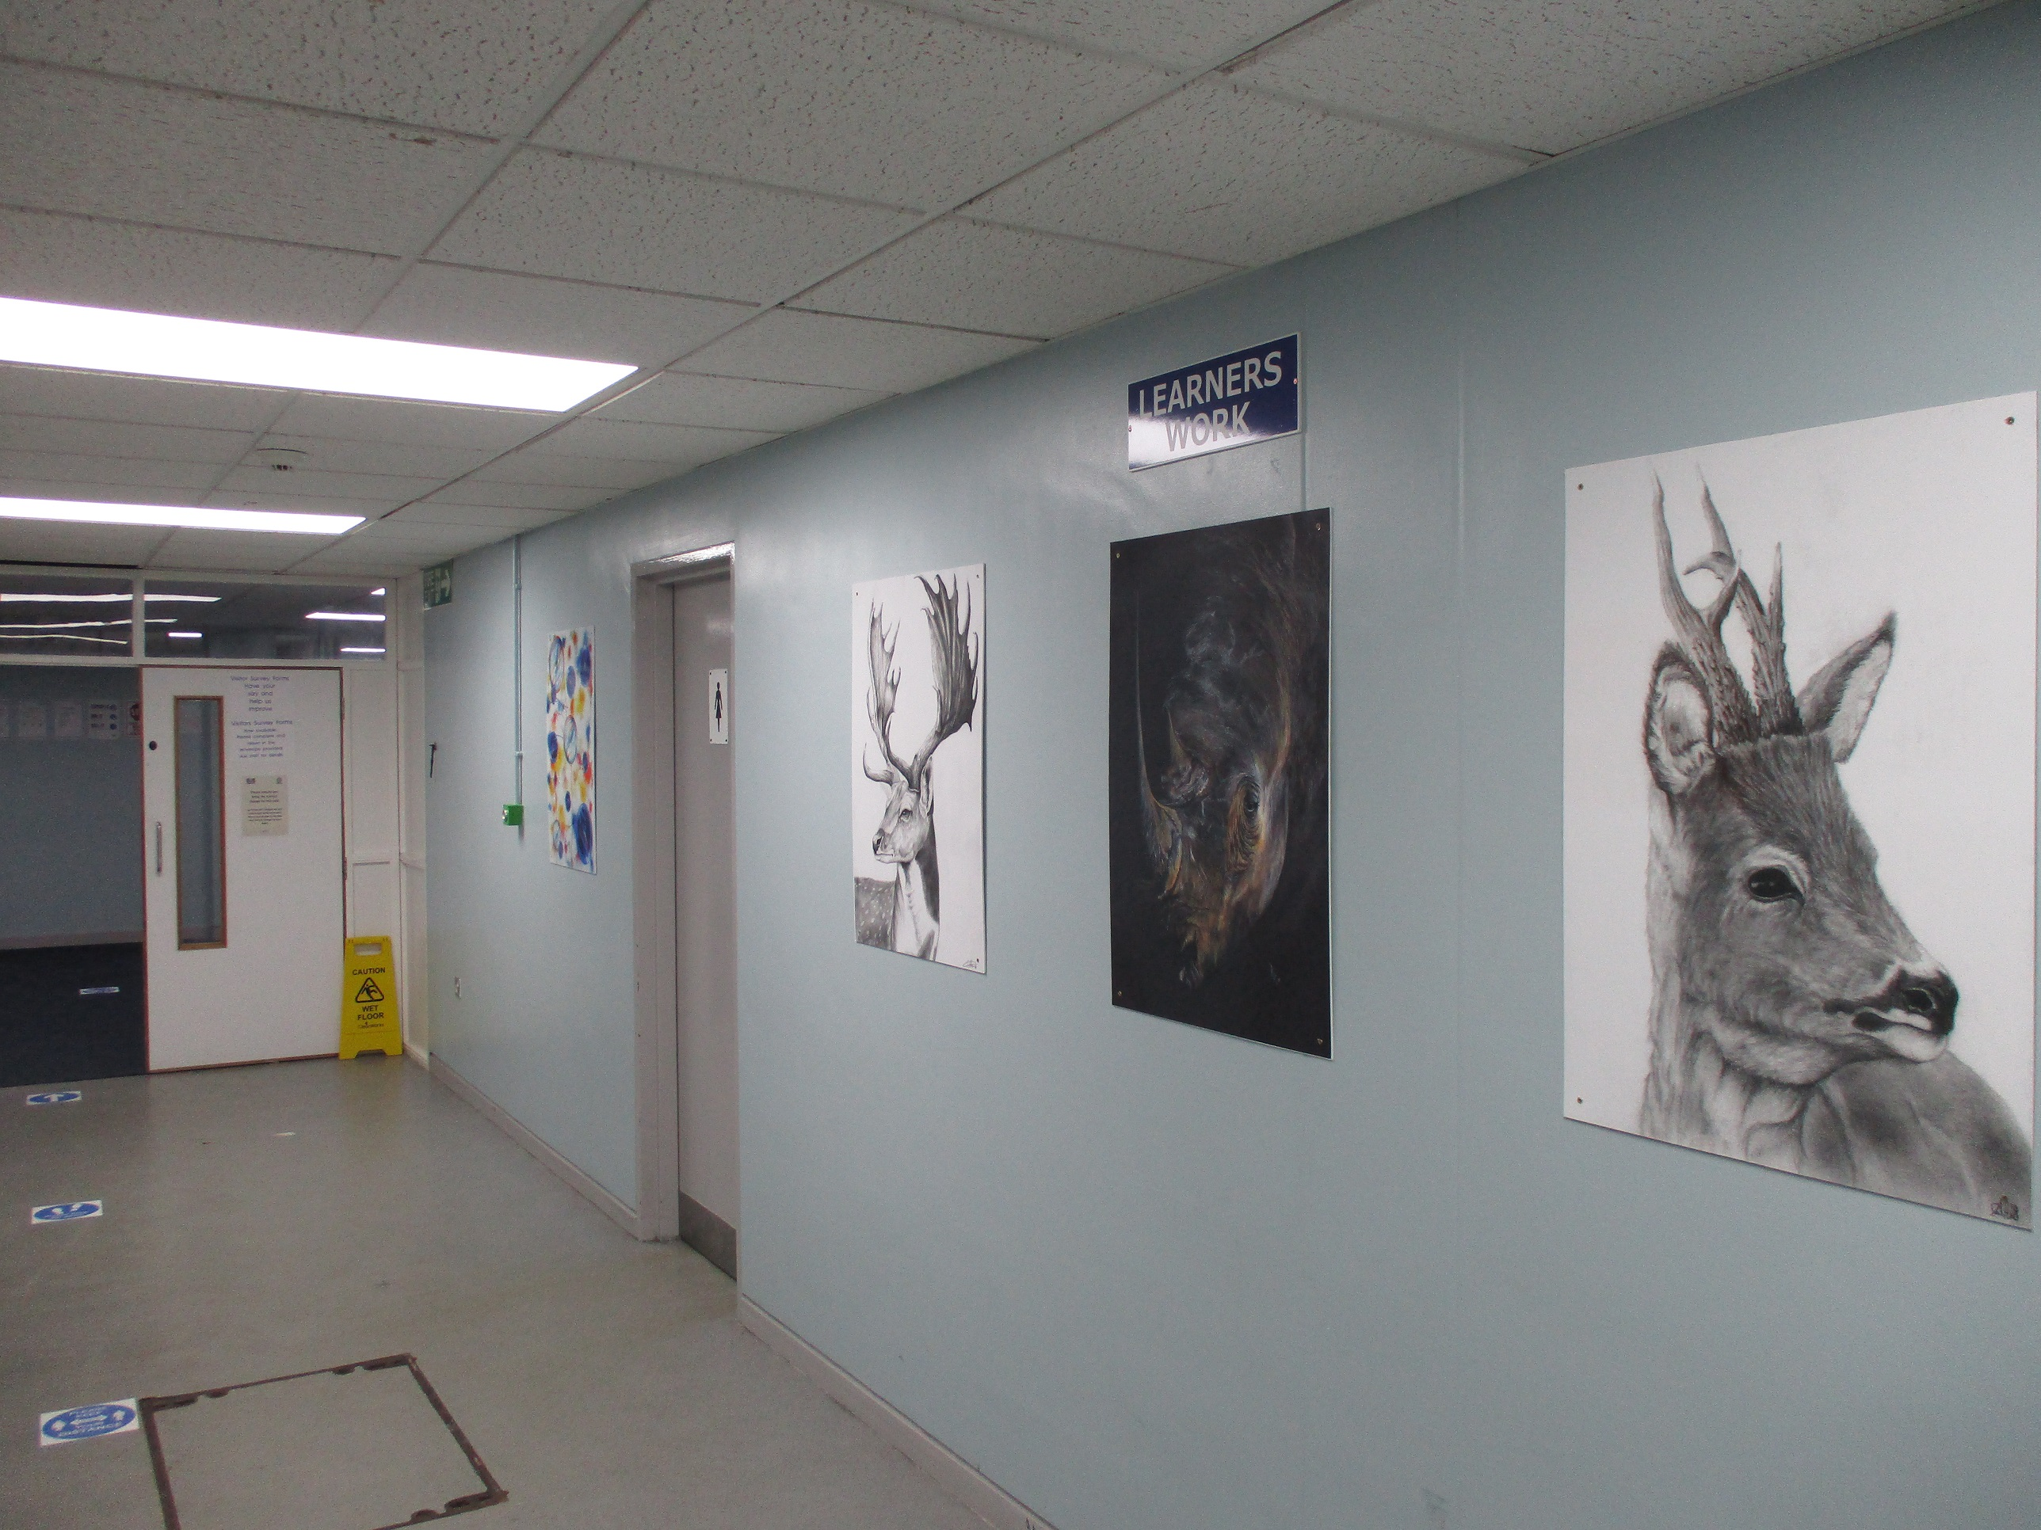
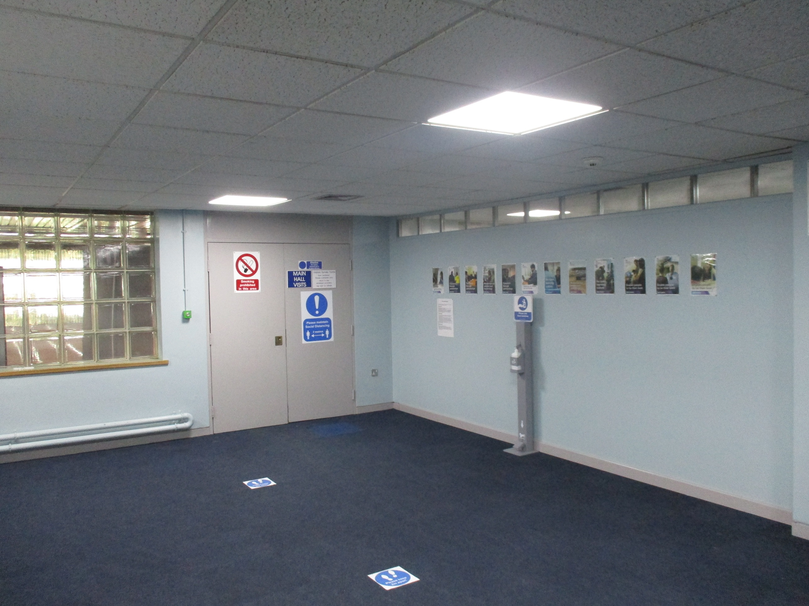  Get Getting to Moorland  By Car- Enter postcode DN7 6BW into the Satnav to find the establishment. Alternatively exit the M18 at Jct 5, onto the M180. Take the first exit, signposted Hatfield, then at the Green Tree public house, turn left. The prison is signposted from here.  By Train- The nearest train station is Doncaster. A taxi from the train station to the prison would cost between £20 and £30.and Littleborough.  By Bus- From Doncaster Frenchgate Interchange take the 84A bus. This will drop outside the visitor’s centre /establishment, and runs a return service. NB This bus journey may take approximately 60 minutes. take any bus from Bus-Stand B. | 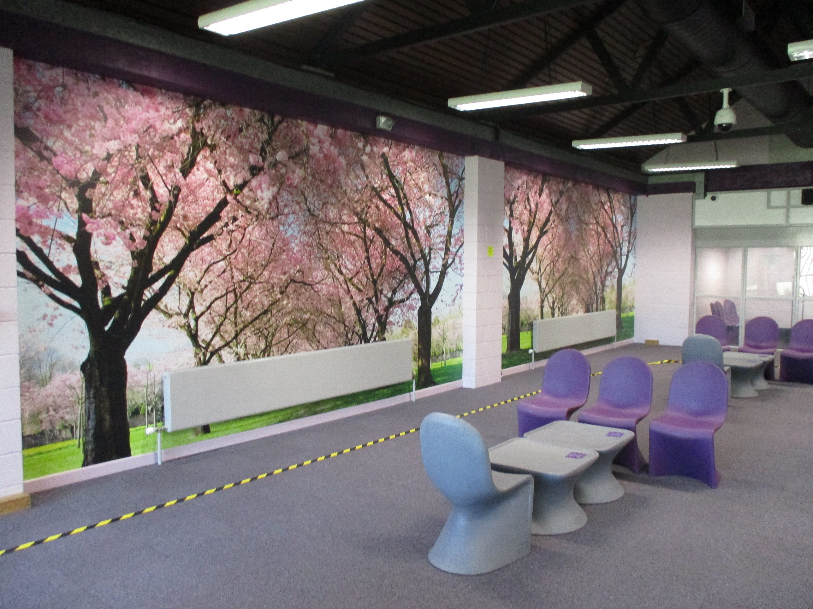
 | Accessibility  If you have a disability, please inform the booking officer when you book your visit, so that any special arrangements can be made. Wheelchairs, their users, adults accompanying them, and assistance dogs may need to be searched. Staff who carry out the searches will do so with sensitivity. Visitors who need physical assistance during their visit must be accompanied by another adult. The establishment’s staff cannot offer personal assistance. There is disabled parking beside the visitor’s centre and there are no steps when entering the centre, or the main gate of the establishment. The Visits Hall is on the ground floor and disabled toilets are available.  If you have difficulty visiting the establishment because of a disability you can discuss this in confidence with the Visitors Centre staff 01302523090
  Getting to Moorland
  By Car- Enter postcode DN7 6BW into the Satnav to find the establishment. Alternatively exit the M18 at Jct 5, onto the M180. Take the first exit, signposted Hatfield, then at the Green Tree public house, turn left. The prison is signposted from here.
  By Train- The nearest train station is Doncaster. A taxi from the train station to the prison would cost between £20 and £30.and Littleborough.
  By Bus- From Doncaster Frenchgate Interchange take the 84A bus. This will drop outside the visitor’s centre /establishment and runs a return service. NB This bus journey may take approximately 60 minutes.
  staff may accept combinations of
  three or more of the following:
  -Birth/Marriage Certificate
  -Bus/Rail Pass with Photograph
  -Bank Credit/Debit Card
  -Young Persons proof of age card
  -NUS Card
  -Rent book/utility bill
  -Library Card.
  Visiting Hours
  HMP Moorlands provides visits at the following times:
  Tuesday 14:30 to 15:30
  Thursday 14:00 to 15:30
  Saturday 14:00 to 15:30
  Sunday 14:00 to 15:30
  The Visitors Centre is open Tuesday Thursday Saturday and Sunday, this is where family, friends and legal representatives check in for pre-booked visits.
To visit someone in HMP YOI Moorland

You will need to bring one of the following forms of identification with you:

-Passport
-Driving Licence
-EC Identity Card
-Employers/Student ID Card
-Bus Pass with photograph
-Red Maternity Book (ID option for children).

If you are unable to produce one of the above,
staff may accept combinations of
three or more of the following:

-Birth/Marriage Certificate  -Bus/Rail card with Photograph  -Bank Credit/Debit Card  -Young Persons proof of age card  -NUS Card (National Union of Students)  -Rent book/utility bill  -Library Card. | 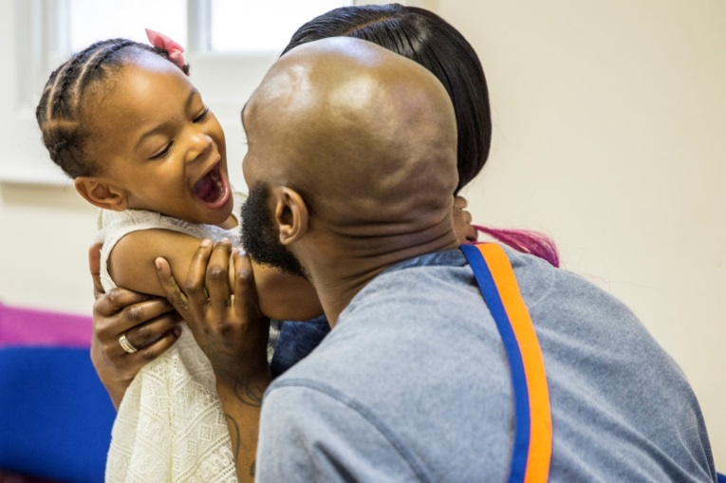
How to book a visit

A family can book a visit using the following methods:
Visits booking line is open on Tuesday and Thursday, between 0900 and 1200 (professional visits) and then 1400 to 1600.
01302 523289
Online by email, website www.gov.uk/prison-visits

When booking a visit you will be asked for the following:
-Name and prison number of the prisoner you wish to visit.
-Your own name, address and date of birth.
-The date you wish to visit.
-The number of people visiting – their names, addresses and dates of birth.
-The relation to the prisoner of anyone under the age of 18 years.

The prisoner is allowed up to 5 visitors per visit (this can include a maximum of 3 adults).

Please be aware that you need to be over the age of 18 to visit alone. Anyone under 18 must be accompanied by an adult.

We ask that all visitors come on their visit clothed modestly i.e. not too revealing/no offensive or inappropriate slogans or logos.
If you are going to be late for a visit please contact the Visitors Centre, as soon as you can. The last entry into the establishment is 30 minutes after the visit start time. 01302 523090

Entering the Prison

You may only take money up to the value of £100 into the establishment for the purpose of purchasing drinks, food and snacks (Smaller notes and change are ideal). This sum of money is between all visitors on the visit, not per person. ID and car keys cannot be taken to the establishment. Both items can be taken up to the gate where they will be stored in a small locker. There is a £1 deposit for the use of these lockers and the key must be returned. On arriving at the gate, you will be required to show your identification. If a visitor does not bring appropriate identification, they will not be allowed to enter the establishment. On your first visit, your details will be entered onto the establishment system (you will be required to have your photograph and fingerprint taken). This makes the process easier and quicker for future visits. All visitors are searched, which will involve passing through a metal detector and a rub-down search. All searches will be carried out sensitively, with respect and courtesy to all individuals. Children are patted down by female staff in front of their parents. All visitors' religious beliefs are respected. There is a private room available should religious headwear need to be removed as part of the search.

Drugs

The smuggling of drugs is a serious offence and therefore will be treated as such. This includes illegal and prescription drugs. If anyone is suspected of smuggling drugs, they will either:

-Be subject to a more thorough rub down search.
-Be placed on a closed, supervised visit.

If you are worried about drugs or are being placed under pressure to smuggle drugs please speak to an appropriate member of staff or contact the establishment by telephone.

Before entering the establishment you may encounter a dog which is trained to pick up the scent of drugs. If a person is identified as being in possession of drugs or any other prohibited item, they may be subject to visiting ban and the police will be informed.

In the Visits Hall
The prisoner will be waiting in the visits hall when you arrive. Normally the prisoner and his visitor(s) sit at a table in an open room, with the other prisoners and their visitors.
Physical contact between the prisoner and visitors is usually allowed briefly at the beginning and end of the visit. The person you are visiting will need to remain seated throughout the visit.


Visitors are able to get up from the seating area to obtain drinks and snacks from the tea bar or to use the toilet. The toilet is situated outside of the visits hall, therefore you may be required to be searched again before re-entering the room.

A visit may be held under ‘closed’ conditions if there are concerns that the visit may be a risk to establishment security, or if there is a risk of unacceptable or illegal activity taking place during the visit. During a closed visit, the prisoner and visitors will talk to each other whilst seated either side of a glass panel. The decision to place someone on “Closed visits,” is only taken in exceptional circumstances, and this is reviewed regularly.

Children

All visitors under the age of 18 years are regarded as children, and must be accompanied on a visit by an adult. This is a requirement of the establishment’s child protection policy. Children must not be left alone anywhere, at any time on the establishment premises, including in the Visitor Centre or in the car park. Pushchairs are available on arrival, which may be used when entering the prison. Nappies and wipes may be purchased in the visits area. Access to baby change facilities is available.

Prohibited items

Amendments to the Prison Act now make it a criminal offence for certain items to be used, brought into or taken out of Prisons without authority
The prohibited items listed below are graded according to their perceived threat to Security and Safety within a Prison. A person (e.g offenders, staff .social and professional visitors) commits an offence if he/she carries out any of the following listed activities without obtaining prior authorisation
- Brings ,throws or otherwise conveys List A , B or C items in or out of a Prison by whatever means
- Causes another person to do so
- Leaves List A, B or C items in any place (in or out of a Prison) intending it to come into the possession of an offender.
- Knowing a person to be an offender, gives List A , B or C item to him
List A items –
- drugs
- legal highs / NPS
- explosives
- firearms or ammunition
- offensive weapon

List B Items –

- alcohol
- mobile telephones
- cameras
- USB sticks/memory cards/ Hard Drives
- sound recording devices (or constituent part of the latter three items)
- wifi / bluetooth enabled devices
- fit bits

List C Items –
- Tobacco tobacco / smoking materials / lighters/ matches are prohibited
- Only one vape / e-cig allowed per member of staff with no refills or charging equipment.
- money
- clothing
- food/frozen food
- drink
- letters
- paper
- books
- tools

It is also a criminal offence to take a photograph or make sound recording within a prison or convey an official document or photograph or personal file in or out of a prison

Help with the cost of your visit

Financial Assistance with Visiting: If you qualify to receive help with your finances such as benefits, you may be able to recoup all or part of the cost of your travel expenses through the ‘Assisted Prison Visits Scheme’. As part of your application, you will need to get a secondary form stamped by prison staff in order to prove your visit took place. You can request a copy of this form at the Visitors Centre.

Visits times
Tuesday: 1400 – 1600 hrs
Thursday: 1400 – 1600 hrs
Saturday: 1400 – 1600 hrs
Sunday: 1400 – 1600 hrs

Working in Partnership
Development and coordination of our local family strategy is led by the Head of Reducing Reoffending, who chairs the local Family Strategy Group. This is a team of both prison staff, from a range of functions, prisoner representatives and partner agencies, who support progression of our work to enhance family engagement.


Pact
Our local family services are provided by Pact (Prison Advice & Care Trust), a charity who have a proven track record of delivering excellent results with families. They provide casework to support the rebuilding and strengthening of relationships, deliver courses to help men with family relationships and offer a play co-ordinator, to deliver supported play during social visits. They additionally offer support to the families of those in our care. Pact have created an information booklet to help visitors understand contact and visiting arrangements and facilities.
Delivery of the Pact service is managed through regular contract management meetings and an annual service review.
PACT – national prisoner family helpline: 0808 808 2003
Prisoner’s families website – prisonersfamilies.org
Email – Moorland@prisonadvice.org.uk

Support for Younger Visitors
We aim to make visiting men at Moorland a positive experience for families and work hard to create a child friendly environment. William the Bear is part of Pact support for our younger visitors. He often joins in with activities that Pact staff are running, such as painting and colouring. Before visiting your loved one, children can email William the Bear with any questions they have about visiting. WilliamTheBear@prisonadvice.org.uk. William may be available to sit with children in the Visitors Centre if they are nervous when they visit.

Doncaster Safeguarding Teams
We work closely with Doncaster Safeguarding Adults and Children’s boards, in line with our regional Safeguarding strategy, to promote the safeguarding of all those in our care and their loved ones, with whom we have contact. We deliver Safeguarding training and briefings to our staff, to ensure they have the right information to support vulnerable adults and children.
Other ways we support Contact  There are many ways in which we support family and significant other contact, these have been enhanced, during the past year by notable advances in digital and technology.    We now have a twitter account, which families can follow for regular updates @HMPMoorland
  Prison Video 
  A welcome initiative has been the introduction of video calling, via the Prison Video Platform. This is available to all people via application and enables families to stay connected and build relationships, where distance, physical health or other barriers, make visits in person difficult.
 |   For people and loved ones, whose first language is not English, we offer translation services via ‘The Big Word’, to ensure they are able to be fully included in life at Moorland.    Mail/email  All people have access to a free weekly letter and the email a prisoner service (www.emailaprisoner.com), which promote family contact. Incoming post is delivered daily.
  
  We offer family days throughout the year, which all people can apply to take part in. These include lunch, activities, and themes, to provide a fun opportunity for men to spend time with their loved ones.
  Full details for each event, will be advertised well in advance. Family days will also be promoted throughout the establishment, in the visitor’s centre and by Key Workers.
  Family Days

Phones/ prisoner voicemail
Our people have access to in-cell telephony, which allows contact with family and friends at a mutually convenient time. We also offer the Prison Voicemail service. Those people, whose family live abroad are provided with additional phone credit, to support them in maintaining contact with loved ones.
Family Concern Line

Our safety line 0800 4961364 is available to raise concerns about a loved one. Where the concern is immediate, contact should be made via the main switchboard 01302 523000. Wherever possible and practical, and with the consent of the man, families may be involved in care and support plans.
Safer Custody helpline
We have a dedicated safer custody helpline which is checked on a regular basis throughout the day, is staff are unable to immediately answer. This phoneline can be used to report any welfare concerns, for those people resident at HMP YOI Moorland
Safer Custody At Risk Hotline: 0800 496 1364
Story Book Dads
This is a national charity, giving the opportunity for dads to strengthen relationships with their children, by reading and recording a bed time story for them. www.storybookdads.org.uk. We also run stories by Dads and ‘Swaps’, which allows men to complete and share work with their children.

Support for People and their Families at Moorland
There are a range of people in the prison, who can offer support in maintaining family ties and encourage the involvement of loved ones in the progression of those in our care.

Chaplaincy team
The Chaplaincy provide an important link with family, via pastoral care, which may involve contacting a family member on first arrival at the Prison, support during bereavement or concern for a family member. They support men and families of all faiths and none.
The Chaplaincy team coordinate our Official Prison Visitors (OPV) scheme. OPVs are volunteers, who are available to visit men, who rarely, if ever, have visits from friends or family members. They may be the only contact a person has with the outside world – hence the motto “Bringing the outside in”. Through regular visits, a relationship is built where trust, empathy and understanding are key.
Chaplaincy support people, where a relative is seriously ill or has passed away and due to recent advances in technology can offer support during a video call for these purposes.
Safer Custody
This friendly and supportive team are often the first point of contact for families who are concerned for the wellbeing of their loved ones in custody. They also ensure family members are able to support people who are at risk of self-harm, through being invited where appropriate and consented to be involved in their support plans.
Induction and Reception Teams
These welcoming staff ensure all men have an identified Next of Kin, so contact can be made in an emergency situation.
They also ensure people are able to make a phone call to a loved one on arrival at Moorland.

Key Worker
All people at Moorland will be allocated a Key Worker, this is a Prison Officer, who will offer support and guidance to aid progression and ensure men feel safe and settled during their time with us. They will promote and encourage family and significant other relationships and where appropriate and in agreement with the person, may contact family members to discuss ongoing work.
IPP Sentences
We recognise the difficulties and anxieties that can be accompanied by a sentence that does not have a distinct end date. As an establishment we will work closely with all such individuals and their families, where appropriate, to help to address identified risks, and work towards a position where everyone has the hope of progression, and ultimately release.
Young Adults
Approximately 10 to 15% of our population is, at any given time made up of those considered young adults (18-25). This group does bring a host of issues. We will continue to work closely with all young adults to address their needs and help them to establish themselves as they return to their communities. Our partner agency, Igneous work with this group to provide “All stars,” courses, specifically engaging this group. It is also important that we can help these people with subjects such a financial planning, benefits, accommodation, and employment, that they may not have faced, prior to custody. Many of these elements are specifically covered in aspects of our educational curriculum.
In 2024 we are going to open a dedicated young adult wing, with a greater emphasis being placed on the needs of this quite often impulsive and less mature, population.
Substance misuse Team – Practice Plus Group

The substance misuse team often jointly work with the family support team to help people address addiction issues, with the consent of the person. The Substance Misuse Team also engages with family days and contact families in relation to providing relevant updates with their progress with the people’s consent. Certificates are able to be provided to be sent out to families in relation to negative urine screens as a way of providing confirmation of motivation. This works really well, particularly when Prison Key Workers are also involved.

Family involvement in sentence and release plans
Moving forward the Offender Management Unit aims to involve families, with the consent of all involved, in sentence, release plans and any other appropriate activity. The offender management Unit encourage people to inform families of parole hearings and apply to attend if helpful.
Staff training and development
Our staff play a vital role in the success of our family services work. Pact deliver ‘Think Family Approach’ training to staff, to enhance involvement in progressing our family strategy. In addition, our Key Workers receive support to ensure they are able to recognise and encourage the importance of family and significant other relationships in supporting people.

Resettlement Hub
Returning to the family home, following a long period of absence can be difficult and a big change to prepare for. There may also be public protection concerns which mean it is not appropriate for somebody to return to the family home immediately upon their release. In these situations, our Resettlement Team, work with partner agencies to find suitable accommodation, help deal with banking and ID issues and seek training or employment opportunities for people leaving custody.
Our Resettlement team, Key workers, and Prison Offender Manager can refer directly to PACT where family support is needed. They also offer information on a befriending service on release, for those who do not have supportive links in the community.
Care Leavers

We are committed to our Care Leavers Strategy and aim to identify care leavers at the earliest possible opportunity, to ensure support is tailored to their needs.
We have appointed a dedicated Care Leaver Coordinator, whose role includes the provision of staff awareness training, co-ordinating care leaver peer mentors, ensuring care leavers have access to support from community services including Personal Advisors and delivering individual support where necessary. The services of Official Prions Visitors and pen pals schemes may also help to bridge the support gaps that some care leavers may experience.
We have two Care Leaver Champions, who arrange regular forums with our care leavers and invite, external agencies to support as required. These are SO S Jameson and POM Andrea Racjan

The sentence planning etc – absolutely fine.

Progress in the Past Year

Through our Family Strategy, we are committed to developing our family services and provision. Whilst there is still work to do, we have seen some real achievements in this area.

- We have consulted with our people in prison and their families, to improve service provision and have generated information material for our people and their families, which is responsive to their needs.
- We have effectively operated our family concern line and where possible, updated families on action taken to keep their loved ones safe.
This has been enhanced during 2023, with the addition of the prisoner family help line, which allows people to contact (email or telephone) the prison directly with any concerns or issues
- We have made and continue to make improvements to both our visits hall and visits centre, to ensure these are more welcoming and our visits hall provides a relaxing environment for our people in prison and loved ones to share quality time.
- We have broadened our family support provision by increasing our Family Support worker hours to meet the needs of our men and their loved ones, giving better family engagement both pre / post, and during visits.

Our Development Plan 2024-25

Performance and Measurement
We are committed to delivering and developing a family service, informed by feedback from our people in custody, and their loved ones. To assist us with our efforts to stay in tune with what our people, their family, children, and Significant others are experiencing we capture client feedback in the following ways, to assist in measuring the effectiveness of our family work.
- Data capture on people not receiving visits, and analysis on reasons why.
- Feedback from our people on the visits experience.
- Family/children/Significant Other feedback on the visiting experience.
- Feedback on Family Day events
- Formal Requests or Complaints from our people and their loved ones.
We monitor the progress of our work within the Children and Families pathway, via quarterly Family Strategy meetings and bi-monthly Reducing Reoffending meetings.
We commit to learning from and progressing HMIP (His Majesty’s Inspector of Prison), MQPL (Measuring the quality of prisoner’s lives) and audit recommendations in relation to our work to support family ties, by including these in our Family Strategy Action Plan, which is reviewed quarterly by our Family Strategy team.
We will review our Family Strategy document annually, to ensure it remains relevant and is responsive to the needs of those in our care and their loved ones.

The Family and Significant Others (FASO) leads at
HMP YOI Moorland are:

Head of Reducing Reoffending (FASO Lead)
Head of Operations
Custodial Managers - Operations Group (FASO Champions)

Useful links
There are many organisations, both charities and government bodies that can offer help, advice and support to the families of those in prison. Below are just a few of those that people may find helpful:
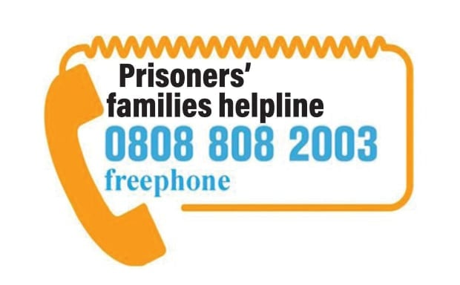

Apex Trust
01744 612 898
www.apextrust.com
Helpline for ex offenders, prisoners, probation staff and employers. Cover a range of issues that affect ex-offenders seeking employment including when a conviction becomes spent, how to find local sources for help, information about the Criminal records Bureau and how to disclose a criminal record to an employer

Caring for Prison Leavers
https://caringforprisonleavers.org/usefulorgs

Forward
020 3981 5525
www.forwardtrust.org.uk
Forward empowers people to break the often interlinked cycles of addiction or crime to move forward with their lives. For more than 25 years they have been working with people to build positive and productive futures. They believe that anyone is capable of lasting change. Their services have supported thousands of people to make changes to create better lives with jobs, family, friends and a sense of community

Prison Fellowship England and Wales:
020 7799 2500
www.prisonfellowship.org.uk
Supporting, through 160 local groups, prisoners, ex offenders and families. Run programmes intending to change prisoners behaviour and attitudes, work outside prison with released offenders and prisoners families including practical support for those families.

Unlock:
01634 247350
www.unlock.org.uk
Independent award winning charity which provides information, advice, training and advocacy dealing with the ongoing effects of criminal convictions.

Proud to Support People and Families through Partnership Working
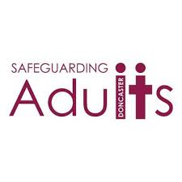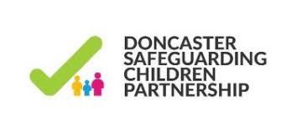



The Farmer report, ‘The Importance of Strengthening Prisoners Family Ties to Prevent Re-offending and Reduce Intergenerational Crime’ Recommended family should be the “golden thread” running through all prison processes. ‘Delivering Effective Family Practice Guidance for HMPPS 2017’ Her Majesty’s Inspectorate of Prisons identify 46 recommendations in relation to children and families; The HMPPS ‘Good industry Practice Measures’ 2019 for Prison family s

