HMP Wandsworth Family & Significant Others Strategy
2025/26

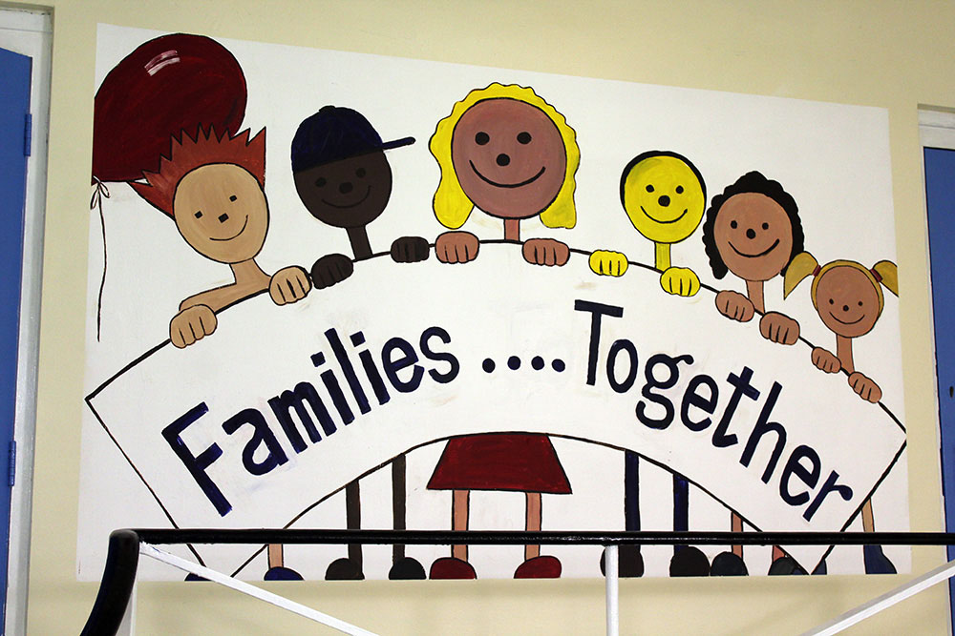

Contents
Families at HMP Wandsworth 2
Current Family Services at HMP Wandsworth 5
Family Days
Social Visits
In cell-phones
E-mail A Prisoner
Assisted Prison Visits Scheme
Letters, Cards and Property
Secure Video Calls
Chaplaincy
PACT
Safer Custody
CGL
Foreign National Support……………………………………………………………………………………………………………………………….
Visitor Experience 9
Improved Engagement 10
Supporting All 11
Partnership Links 12
How we will measure our progress 13
Further Information/Reading 15
FaSO lead and Champion Job Description…………………………………………………………………………………………………….15

Summary for families and significant others

This document explains how HMP Wandsworth supports contact between prisoners and their families or significant others. It covers visits, video calls, support services, family days and how we involve families in welfare and casework. It also explains who to contact if you have concerns about someone’s safety.

Families at HMP Wandsworth

Here at HMP Wandsworth in 2025, eight years after the publication of the Farmer Review, we remain as committed as ever to help maintain, promoting and improve our prisoners’ relationships with their families and significant others.

In continuation of our family strategy for 2024/2025, the strategy for 2025/2026 is to continue to re-build our visits offer and ensure that adequate opportunities are available for our prisoners to actively maintain face-to-face relationships outside of prison. This strategy is delivered in line with the HMPPS Family Policy Framework, the Lord Farmer Review recommendations and relevant safeguarding legislation. Our approach supports the national expectation that every prison strengthens positive family and significant other relationships where this is safe and appropriate.
We have not lost sight of the fact that relationships are an incredibly important motivating factor in a prisoner’s decision not to re-offend. Focusing on family relationships encourages prisoners to consider the consequences of their actions, focus on their responsibilities, and to try to be good role models for their children. We recognise the powerful role that family and significant others play in helping our people come to terms with their imprisonment and maintain high behaviour standards whilst they are with us.
We also know however, that many of our prisoners, for a variety of reasons, do not necessarily have strong connections outside of prison. We also realise that not all relationships are positive or conducive to moving away from offending and should not be promoted by us. The current strategy therefore has a lot of focus on those who don’t get regular visits or have limited positive family ties because, in the words of Lord Farmer - “If prisons are truly to be places of reform we cannot ignore the reality that a supportive relationship with at least one person is indispensable for a prisoner’s ability to get through their sentence well and achieve rehabilitation.” All family contact is subject to safeguarding checks. Staff consider risks related to domestic abuse, child protection or vulnerability before approving or supporting contact. Decisions are made in conjunction with Safer Custody, Public Protection, Social Care and external agencies where needed. This ensures that any family contact promoted by the prison is safe, proportionate and clearly recorded.

For all these reasons family work remains a critical pillar of our commitment to making HMP Wandsworth a safe and purposeful place as it possibly can be, as well as protecting the public by helping people to live law-abiding and useful lives once they are released.
The purpose of this document is to inform readers of the current family support services on offer for prisoners and families alike here at HMP Wandsworth. We also want to share our future ambitions for how these are improved and evolved over the coming year. We want this to be a document that prisoners, their families and prison staff can all engage with, contribute to and learn from. I hope you will find it useful.
Ron Burke
Head of Reducing Reoffending
Head of Visits and Family Ties
HMP Wandsworth

Current Family Services at HMP Wandsworth
Social Visits
Wandsworth usually offers in person social visits Monday – Sunday except Fridays. The schedule of this does change but time slots are usually readily available.
Families and friends have to be added by the person in prison and approved. Visitors can then book slots through the booking line (0300 060 6509) or online through the GOV.UK website.
Visits are for 1-hour sessions, with double session readily available.
Refreshments are available to purchase and there is a play area for children.
In addition to the refreshments, visitors can purchase goody bags for their families to take back with them after the visit’s session.
Our current visits timetable is as follows:
Monday – Thursday
10:30 – 11:30
13:30 – 14:30
15:30 – 16:30
(March 2026 no social visits Tuesday AM/Wednesday AM)
Saturday and Sunday
09:00 – 10:00
10:30 – 11:30
13:30 – 14:30
15:30 – 16:30
Managing complex family situations
Where concerns exist about a relationship, staff can refer cases to Public Protection, Social Care, Safer Custody or the FaSO Lead for review. Restrictions, supervised contact or alternative arrangements may be put in place. Decisions are always recorded and reviewed regularly. This maintains safety while supporting appropriate meaningful contact where possible.
Family Days
HMP Wandsworth arranges ‘family days’ approximately once a month.
Family days normally have a particular theme, for example Mother’ day, Easter, Christmas or Sports day, and give families an opportunity to have longer visiting hours in a more relaxed and fun environment. They typically last all day and are centred around enabling deeper and more meaningful family ties than what might be achieved in a typical 1-hour visit.
Prisoners can apply for family days and the criteria is made available through internal communication services with prisoners via radio Wanno and the kiosk. The criteria are generally that prisoners have had visits in the last 3 months with their children and do not have adjudications for finds like mobile phones, weapons or drugs when in custody. Anyone involved in any violent related incident is also not considered for family days.
In cell phones
All prisoners at Wandsworth have access to in-cell phones which means they can make calls 24 hours a day.
Most prisoners are given a PIN on their first night in custody with a limited amount of credit. Within a few days they can upload more credit and add contact numbers of those they want to call.
Prisoners can make up to 300 minutes of calls a day, individual calls allowed up to 30 minutes duration, with 1 minute interval in between each call.

M
E-mail A Prisoner
You can ‘e-mail’ a person in prison through the website https://www.emailaprisoner.com/This service allows family and friends to send an electronic message which is printed off and delivered to a prisoner the next day, which they can then reply to by writing a response. There is a small cost for the service.

Secure Video Calls
Secure Video calls are available for prisoners use at HMP Wandsworth. These are booked via the ‘prison video app’ available from Google Play or the Apple store app. More information available online by searching ‘secure video calls on the GOV.UK website.’ Secure video calls are held Monday – Friday, usually in the afternoons.
They allow prisoners to have face to face video contact with families through a phone or laptop, similar in many ways to ‘a secure ‘Skype’ call. and are usually 30 minutes long.
Assisted Prison Visits Scheme
HMP Wandsworth partakes in APVS which in some circumstances can contribute money towards the cost of visiting somebody in prison if you are in receipt of certain benefits or have a health certificate to get help. More information is available at: www.gov.uk/help-with-prison-visits
Letters, Cards and Property
Families and Significant others can send unlimited letters and cards to prisoners. These typically take 1-2 days to pass through security and arrive with prisoners once they get to the prison. Prisoners can also send out letters through buying stamps on the canteen.
Families and significant others can hand in property such as clothes and books. The person in prison has to book an appointment and have it confirmed first, and then the property can be handed in at the prison at the agreed time.
Socks and boxers are the only items that can be handed in before a visit without needing an appointment. Similarly, books and games can be purchased directly from Amazon and sent into Wandsworth for prisoners without prior permission.

Chaplaincy
The chaplaincy at HMP Wandsworth supports prisoners and their families in a variety of ways, perhaps the most significant being ‘major life events’ including illnesses, bereavements and funeral support, as well as marriages. In the cases of close relatives, the chaplaincy works to ensure that prisoners are able to visit their sick family member or attend their funeral, as well as providing pastoral care for other types of life events.
The Official Prison Visitors, a ‘befriending’ service which connects volunteers with prisoners, also operates through the Chaplaincy. This provides a vital companionship opportunity for those with limited family ties.

Safer Custody
Safer Custody at Wandsworth receives information from a variety of sources, including family and friends, about the safety of prisoners. Concerns around welfare, health or violence, drugs and debt should be reported to saferprisonswandsworth@justice.gov.uk who will act on these concerns.
If you have a concern about someone in Wandsworth which is urgent but not life-threatening call 02085884593 and leave a message
You can also share non-urgent concern by following the below link.
HMP Wandsworth Safer Custody Contact Form | Prisoners' Families Helpline
If you have a concern that you believe is life threatening, please call
0208 588 4358
and ask for the Orderly Officer.
Please note calls to this number will only be actioned if they are thought to be a genuine emergency. All other concerns will be responded to by the Safer Custody team in office hours.
Safer Custody also oversee the ACCT process for those who may be at risk of self-harm or suicide. Families are welcome to join these reviews to improve the care for those subject to them.

PACT
HMP Wandsworth contracts out its family provider services. The current provider is Prisoner Advice and Care Trust (PACT) We work closely with PACT to deliver a number of services for families and significant others including:
- A play worker to provide a welcoming space for children which allows them to play safely and maintain attachment with their imprisoned parent or relative during visits.
- Visitors Centre – creating a welcoming environment for visitors, providing useful information and post/pre-visit emotional support for difficult visits.
- An up-to-date website containing information about visiting HMP Wandsworth and prison more generally (www.prisonadvice.org.uk/hmp-wandsworth)
- A full time Family Engagement Worker who provides casework and advocating services, liaising between prisoners, families and other relevant professionals within the prison and community, and signposting to other organisations that can provide specialised advice and support.
- Family Links Visits – A quieter visiting room with supervision from PACT worker for visits with more complex needs between children and their imprisoned parent
- Keeping family members informed and involved in their love one’s healthcare advocating for and enabling families to be involved in care planning.
- Supporting general mental health and wellbeing- offering one to one support and attending ACCT reviews offering a family focused point of view.
- Family Groupwork - delivery of relationship courses to prisoners via in cell packs and family-based courses, including ‘Going home’ and ‘Dads reconnected’.
- Family legal clinic-Supporting prisoners with free legal services with family issues such as contact with children.

CGL
Change Grow Live provide family services as part of their provision for those with substance misuse problems and have a dedicated family liaison officer.
The CGL Family service is designed to support clients who are currently working with the CGL services for their substance misuse. They work in helping clients develop skills that will help them to stay connected to family/significant others whilst in prison. Support is offer through one-to-one key working sessions tailored to an individual’s specific needs and goals pods/programmes exploring issues in a group setting and in cell packs focused on specific skill development in better maintaining relationships.
The Family service can also help with:
- Developing skills to learn how to stay connected to family/significant others (SOs) whilst in prison.
- Developing parental skills and capacity through 1:1
- Support in processing loss & living with separation.
- Support with developing skills for reintegration back into the family pending release.
- Liaise with organisations in the prison cantered on reconnecting families/social networks.
- Making referrals to organisations to further support specific needs
The Family service also offers 2 group programmes:
- ‘Keeping In Touch’ group is an opportunity for the clients to get together and make gifts and cards for their loved ones.
- ‘Building Better Relationships’ is a four-day programme designed at looking at family history, past behaviours, anger management and goal setting for relationships.

FOREIGN NATIONAL SUPPORT
HMP Wandsworth holds a large cohort of foreign national prisoners. To reduce isolation, the establishment provides a foreign national support service delivered by CATCH 22 alongside two Foreign National Specialist Officers.
The service is offered to all prisoners flagged as foreign nationals. Each person is during induction and asked a set of basic questions to check their wellbeing and to identify any immediate needs. Support includes access to a solicitor, contact with embassies, communication with family, and help understanding the prison regime if it is their first time in custody. Translation services are used where required so that prisoners can communicate their needs to relevant departments.
Additional support includes guidance on booking social visits and secure video calls. Small grants are available for foreign national prisoners who arrive without funds to contact family. The team also assists those with limited English on immigration and bail matters.
To reduce isolation and build community, CATCH 22 encourages purposeful activity sessions for foreign nationals, for example themed events and access to a coffee morning for prisoners who do not receive visits. These activities focus on creating supportive networks and offer emotional and wellbeing support facilitated by peer mentors, staff, and the two Foreign National Specialist Officers. We expect this approach to continue with the new support provider.
Partner organisations provide further help. Book visits on an ad hoc basis to support immigration bail applications and assists with drafting legal letters relating to lost property in police or prison custody.
A foreign national support group operates for those who have no family ties or friends. Around a dozen volunteers currently conduct these visits at Wandsworth.
All foreign national prisoners receive a foreign national PIN to maintain family contact. They are encouraged to use this alongside secure video calls, and they may exchange visit orders for additional video calls. They also receive 5 free minutes of phone credit each month to support family contact.
The establishment runs a monthly coffee morning for those with no outside contact, again focused on community building and structured peer support. This coffee morning is available for all who have limited social visits.

Visitor Experience
We want to achieve:
- Visitors can easily and quickly access information about how to visit Wandsworth once a family member or significant other has been sent there.
- They can book their desired visit easily.
- They find the visiting experience comfortable and as stress-free as possible.

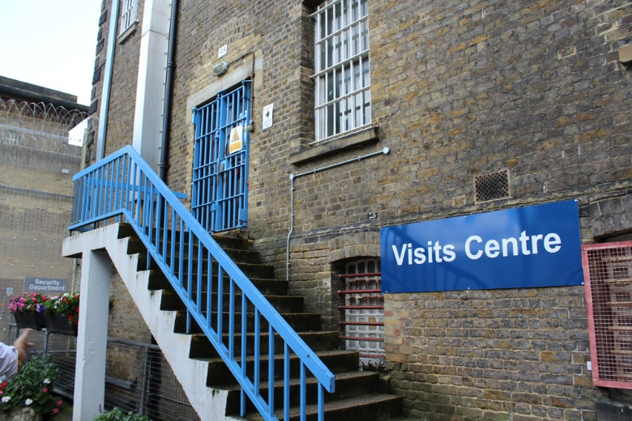
How will we deliver this in 2025:
- Produce a digital platform with all the information needed and made accessible to all the families and significant others who are sent to our custody (Ongoing)

- We will develop a new programme of visits that responds to the needs of our families and significant others. (Completed)

- We will complete regular programme of monthly Family Days and build on the overwhelmingly positive feedback of previous sessions. We will continue to review our application processes to ensure they are fair, transparent and do not punish children for their parents’ behaviour whilst in prison (ongoing)
- We will re-establish our routine feedback process in association with PACT so visitors can easily log compliments and complaints about the process inside and outside the prison. Any issues that are identified are promptly remedied. We will also conduct 4 x surveys a year with our Family Service Provider (Ongoing)
- We will deliver ‘Hidden Sentence' training to visits staff to increase their awareness of the value of Family Ties (Ongoing)

Improved Engagement
What we want to achieve:
- Family members are valued across the prison and involved in the journey of our prisoners.
- We create an environment that supports and improves family contact beyond just the provision of social visits.
- Families and significant others would have the opportunity to feed into our strategy and direction
- Family contact is always balanced against child‑protection checks.

How we will deliver this in 2026:
- We will work with Safer Custody to review and streamline ways family members can report safety information about their loved ones to the prison (
- We will work with Safer Custody and our Family provider to get families more involved in case work of our prisoners involved in violence or self-harm. We will monitor data around involvement of families in ACCT reviews and CSIP (ongoing)

- We will re-tender our contract with the family service provider to improve the link between the Family Engagement Service and induction. We will use this to assess the needs of every person arriving at Wandsworth, and signpost them to the necessary services and information. As part of this we will implement a peer-to-peer family ties orderly group on induction wing (Ongoing)

- We will improve our governance of the Family Provider contract by asking for, and scrutinising quantitative and qualitative data around the usage and impact of the Family Engagement and Support workers (ongoing)

- We will modernise our engagement opportunities, introducing online Q&A sessions bi-monthly with managers in the prison to ask questions and get updates (to begin soon)

- All residential staff, Keyworkers, Case Administrators, Workshops and Education teams contribute to strengthening family ties. Keyworkers encourage every prisoner to maintain at least one meaningful contact, monitor barriers and raise issues with the FaSO team. Family contact should be considered in IEP discussions, incentives planning and sentence management.

Supporting All
What we want to achieve:
- Fully understand the reasons why high proportion (approx. 1/3rd) of our demographic does not receive social or secured video visits
- We take active steps to reduce social isolation for those who do not receive visits or have strong family ties.
- Ensure whole prison, in particular all residential wing staff are actively engaged in improving family ties.
- Increase the use and support of secured video calls for foreign national prisoners to enable they maintain family ties. This is especially important for those with families abroad.
- Organise a family day for foreign national prisoners and family for them to have a more relaxed and friendly environment to support their loved ones
How we will deliver this in 2025:
- We will continue to complete a comprehensive data collection exercise to gain a deeper understanding of why it is that so many of our prisoners at HMP Wandsworth do not get visits including: surveys, focus groups and analysis of existing data. We will use this to identify and implement solutions (ongoing)

- We will continue to improve our family provision for Foreign Nationals by targeting the secure video calls service more towards them. We will work to enable those with relatives abroad or 50+ miles away the opportunity to have longer Video Visits (Ongoing)

- We will re-tender our Family Services Provider contract and introduce contractual obligations and KPIs to ensure provision is more targeted at those who do not receive visits, including Foreign Nationals (Ongoing))
- With the reintroduction of key-working, we will be re-rolling the up-skilling programme for all OMIC key-workers to enable them to encourage every prisoner to maintain at least one meaningful contact outside of prison (ongoing)

- We will work with our OMU to implement a clearer process for facilitating accumulated visits at other establishments and accommodating them at our own (ongoing)

- We will ensure that 100% of prisoners without visits are supported are identified and offered support by utilising the keywork scheme to provide guidance and emotional support. The head of operations would implement a quarterly review process to track prisoners without visits and coordinate interventions with residential and safety teams.

Partnership Links
What we want to achieve:
1. develop relationships with new partners and strengthen existing ones to support us delivering meaningful Family Ties at Wandsworth.
How we will deliver this in 2025:
- We will rebuild links and develop new ones with organisations such as Family Always Matter, Storybook Dads, Prison Reading Group, Care for the Family and SafeGround.
- We recognise the value of parenting and family-based courses as a useful intervention for our population, particularly those on remand. We will look to continually expand our provision of these courses in partnership with our Family Services provider

- We will have more joined up approach with other internal teams who provide invaluable family services including chaplaincy and our foreign national support provider.
- We will introduce a bi-weekly Peer coffee morning for foreign national prisoners without family visits to provide a structured support network, ensuring that at least 50% of eligible prisoners attend one session. We will track engagement through attendance record and participant feedback survey to measure impact and improve sessions.

- We will continue to develop a bi-monthly collective ‘best practice’ family forum for these services to share their work and best practice
- We will establish an improved working relationship with Wandsworth Borough Council and other local councils. We will look at ways we can link our family work into the work the borough councils do, including improving the working relationships with local schools who have children with parents at HMP Wandsworth

- Our OMU department will establish links with Wandsworth Virtual School to enable passing of information to personal advisors for those who are care leavers or care experienced (ongoing)

How we will measure our progress
- In our 2021 inspection, 17% of our prisoners said a member of staff had encouraged them to keep in contact with a family member or friend. This support and encouragement by staff increased the take up of visits by 70% of the population as stated in our 2024 HMIP inspection report.

- Our data tells us that an average of 35% of prisoners do not receive visits at HMP Wandsworth. We will monitor this weekly. On analysis, this is due to the large volume of prisoners with no family in the UK.
- We monitor the weekly usage of Secure Video Calls and aim to further increase this is the need arises.

- We know that our take up of social visits is currently very high at an average on 88%. We aim to ensure that we gradually create enough extra to re-instate the ability of our remand and enhanced prisoners to access their visit entitlement without significantly increasing this figure.

- We monitor the caseload of the Family Engagement Worker which is currently around 11% of the population. We will define “positive outcomes” in Family Engagement Worker casework as demonstrable improvements in communication, safeguarding clarity, conflict resolution or increased contact between prisoners and families. These will be captured through structured case notes and reviewed bi‑monthly.

- We aim to see monthly increases in the number of families being involved in ACCT review and/or CSIP management.

- We aim to ensure that there are not instances of repeat complaints raised by visitors about any one issue.

- We aim to find that our focus groups with prisoners are telling us they feel HMP Wandsworth is largely a place which supports family ties well.

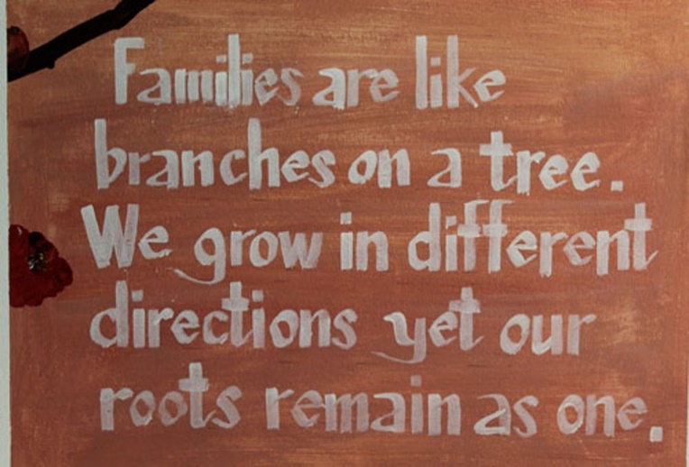

Further Information/Reading

HMP Wandsworth Gov.uk website
Wandsworth Prison - GOV.UK (www.gov.uk)

HMP Wandsworth PACT
HMP Wandsworth | Prison Advice and Care Trust
wandsworth@prisonadvice.org.uk
Visitors Centre: 0208 588 4351 (Monday - Thursday from 8am - 5pm).

Families Helpline
HMP Wandsworth | Prisoners' Families Helpline (prisonersfamilies.org)
Safer Custody Line
If you have a concern about someone in Wandsworth with is urgent but not life threatening call 02085884593 and leave a message
If you have a concern that is life threatening call 02085884358/3930 and ask for the Orderly Officer
HMP Wandsworth key Contacts
Family and Significant Others Lead – Governor Buke
Family and Significant Others Champion – Custodial Manager Reid & Supervising Officer Cunningham

HMP Wandsworth 2024 Inspection Report
https://hmiprisons.justiceinspectorates.gov.uk/hmipris_reports/hmp-wandsworth-urgent-notification/
HMP Wandsworth Independent Monitoring Board
Home - Independent Monitoring Boards (imb.org.uk)

Lord Farmer Review
6.3664_Farmer Review Report (publishing.service.gov.uk)

FaSO Lead – HMP Wandsworth

Governance, Oversight and Role Purpose

Ron Burke, FaSO Lead and Head of Reducing Reoffending, holds overall responsibility for the Family and Significant Others (FaSO) strategy at HMP Wandsworth. This includes compliance with national HMPPS Family Policy and alignment with the Farmer Review principles. The FaSO Lead coordinates, develops and delivers initiatives that strengthen family ties, support prisoner wellbeing and promote safe, positive and meaningful contact between prisoners and their families or significant others.

A quarterly Family Ties Governance Meeting, chaired by the FaSO Lead, oversees performance and risks. The meeting reviews data, complaints, family engagement activity, progress against targets and any identified concerns. Residential Custodial Managers, Visits, OMU and Safer Custody submit updates into this forum. Key actions are recorded and escalated to the Senior Management Team.

Key Responsibilities

• Lead the development and delivery of the FaSO strategy within HMP Wandsworth.

• Oversee family support services, including visit processes, communication pathways and safeguarding considerations.

• Work with internal teams, external agencies and voluntary organisations to improve family engagement.

• Monitor compliance with relevant HMPPS policy frameworks.

• Provide guidance and training to staff on effective family engagement practice.

• Analyse data, produce reports and identify areas for improvement.

• Support complex case management where family related risks or vulnerabilities are present.

FaSO Champion – HMP Wandsworth

Job Holder: Simon Reid
Job Purpose:
The Family and Significant Others (FaSO) Champion supports the development and delivery of initiatives that strengthen family ties and promote prisoner wellbeing. The role champions best practice across the establishment, ensuring that all departments contribute to a supportive, child‑friendly, and family‑focused regime.
Key Responsibilities:
• Act as the visible point of contact for FaSO matters within HMP Wandsworth.
• Promote and embed the local and national family strategy across all wings and departments.
• Support staff in understanding the importance of family engagement and its contribution to rehabilitation and reducing reoffending.
• Liaise with the FaSO Lead, Visits Team, Safeguarding staff, and external agencies to ensure consistent practices.
• Contribute to family‑focused events, interventions, and communication pathways.
• Monitor family‑related issues raised by prisoners and escalate where needed.
• Assist in identifying barriers to family contact and suggesting improvements.

