HMP Elmley and Pact
Family and Significant Other Strategy.



Support Families
Support Prisoners.
Index.
Prevent
Re-Offending.
Index and Translation | Page 2
Overview | Page 3
Why should we focus on Children and Families? | Page 3
Governance | Page 3
Progress | Page 4
Public Protection | Page 5
Offender Management in Custody | Page 5
Accommodation on Release | Page 5
Visitor Searches | Page 5
Feedback and Complaints. | Page 5
Safer Custody | Page 6
Access to Support Services. | Page 6
Getting to Elmley | Page 6
Contact Points / Emergency Contact | Page 7
HMP Elmley Visitor Centre | Page 8
HMP Elmley Visits Hall | Page 9
  - Top 10 preferred languages – C Nomis October 2024.
English | This information can be translated upon request. Please ask a member of staff for assistance.
Albanian | Ky informacion mund të përkthehet sipas kërkesës. Ju lutemi kërkoni një anëtar të stafit për ndihmë.
Lithuanian | Queste informazioni possono essere tradotte su richiesta.  Si prega di chiedere assistenza a un membro del personale.
Russian | Эта информация может быть переведена по запросу. Пожалуйста, обратитесь за помощью к сотруднику
French | Ces informations peuvent être traduites sur demande. Veuillez demander de l'aide à un membre du personnel.
Romanian | Aceste informații pot fi traduse la cerere. Vă rugăm să cereți ajutor unui membru al personalului.
Polish | e informacje mogą zostać przetłumaczone na żądanie. Poproś członka personelu o pomoc
Serbian | Ове информације се могу превести на захтев. Замолите члана особља за помоћ.
Arabic | يمكن ترجمة هذه المعلومات عند  الطلب. يرجى طلب المساعدة من  أحد أعضاء فريق العمل
Bulgarian | Bu bilgiler talep üzerine tercüme edilebilir. Lütfen bir personelden yardım isteyin. Metni buraya çevirmek için yazın

Overview.
In 2017, the Farmer Review highlighted the importance of strengthening family ties within prisons. It found that maintaining positive relationships between prisoners and their families or loved ones can play a vital role in reducing reoffending and breaking cycles of crime across generations. Research from the Ministry of Justice shows that prisoners who receive family visits are 39% less likely to reoffend than those who do not.
At HMP Elmley, we have embraced these findings and aligned our approach with the Farmer Review. We’ve worked hard to embed what Lord Farmer calls the “golden thread” – the principle that strong family relationships should run through all aspects of prison policy and practice. This means creating opportunities for meaningful contact and support, helping prisoners stay connected with their families in ways that promote rehabilitation and safer communities.
Why should be focus on children and families?
At HMP Elmley, we understand that strong family relationships are essential for helping people turn their lives around. Staying connected with loved ones not only reduces the risk of reoffending but also promotes stability and emotional wellbeing. These positive links can lower anxiety, self-harm, and depression, creating a safer and more supportive environment for everyone.
Family connections play a key role in rehabilitation and in building a safer, more stable prison community. That’s why we actively listen to feedback from both prisoners and their families. We’ve scheduled focus groups with prisoners and are gathering input from visitors to help us reflect on what’s working and where we can improve. This feedback will shape how we deliver Family Services in the future.
We share the vision set out in the Farmer Review, which calls family ties the “golden thread” running through all prison policy. Looking ahead, we’ll continue to introduce new initiatives that strengthen these relationships, guided by both local strategies and the Review’s recommendations.
Our commitment is clear: we will keep reviewing and improving our Family Services in partnership with our provider, Pact, to ensure families remain at the heart of rehabilitation.
Governance & Assurance
The Family Pathway at HMP Elmley is overseen by our Senior Managers, Joe Rook and Harry Clark, who lead on Reducing Reoffending. This work is managed through a range of forums and meeting structures to ensure accountability and continuous improvement, including:
- Senior Leaders Team (SLT)
- Pact Performance Meetings
- Reducing Reoffending Meeting
- Quality Improvement Group
- Family Forum – Head of Reducing Reoffending attends the visits centre monthly to speak to families and gain feedback.
In addition, we have a dedicated Family Services Champion, Custodial Manager Alby Gray, who plays a key role in driving this work forward and ensuring families remain central to our approach.
Progress
So far, we’ve taken several important steps to strengthen family ties and address the priorities highlighted in the Farmer Review:
Family-Friendly Visitor Centre: Our Visitor Centre provides a welcoming environment for families and is staffed by dedicated Pact Family Workers who offer support and guidance.
Storybook Dads: Through our library, all prisoners can record stories for their children, helping maintain meaningful connections. We’ve also delivered creative courses where prisoners design and write stories that are published into books—a hugely popular initiative we plan to continue using the DPS system.
Family Days: We aim to hold 13 Family Days each year, including opportunities for wider family members to visit, ensuring everyone can maintain important relationships. We also offer 2 additional family days for those engaging with Drug and Alcohol services (Change, Live Grow – CGL).
Family-Friendly Catering: Working with Pact, we’ve introduced themed days around key events and celebrations to make visits more enjoyable.
Fair Access to Family Days: We’ve reviewed our allocation process to ensure all children have the right to spend time with their parents in custody.
Secure Video Visits: Available on application, this helps families to stay connected when in-person visits aren’t possible.
First Night Support: Pact now plays a key role in our induction process, offering advice and guidance on family contact during what can be a stressful time.
“You Said, We Did” Feedback: Visitors can share their views via feedback forms in the Visitor Centre. This input informs our Reducing Reoffending strategy, and actions taken will be published for transparency.
Specialist Support: Pact provides help for families involved with social services or where children are entering care. They also offer post-visit support and work closely with our Safer Custody team to monitor welfare. Additionally, new dads can receive a special baby photograph to celebrate their growing family.

Public Protection & Victim Awareness
At HMP Elmley, we are committed to encouraging positive family connections wherever it is safe and appropriate to do so. We work closely with specialist teams, including our Public Protection Team, to make sure these interactions take place in a secure and supportive environment. This approach ensures that the safety and wellbeing of both family members and prisoners are always our top priority, while considering all relevant factors before facilitating family contact.
Offender Management in Custody (OMiC)
As part of our Officer Key Work scheme, we ensure that every officer has a thorough understanding of the family services available at HMP Elmley. The Head of Reducing Reoffending works closely with Pact and all key workers to make sure we are actively supporting positive family relationships. To reinforce this commitment, discussions about family are built into the structure of key work sessions, ensuring this vital area is consistently addressed.
Accommodation on release
Stable housing is essential for successful reintegration and reducing reoffending. At HMP Elmley, we have a responsibility to house Care Leavers aged 18 -24 immediately upon release and work with all prisoners before they leave custody to secure suitable housing. Our Resettlement Manager coordinates with local authorities and councils to plan ahead and meet individual needs, giving people the best possible start after release.
Visitor Searches
All visitors are searched in line with policy, always with respect and dignity. Babies and children are searched sensitively and only under the supervision of a parent or guardian. We also make appropriate arrangements for visitors with disabilities and address individual needs on a case-by-case basis. Both Pact and prison staff work hard to ensure the process is as smooth and positive as possible, minimising any negative experiences during visits.
Feedback and Complaints
All visitors have the right to raise a concern or make a complaint about their visit experience. You can speak to staff in the visits hall or the Pact team in the Visitor Centre for guidance on the process.
We also welcome feedback to help us improve. A feedback book is available in the Visitor Centre and is regularly reviewed by managers. In addition, our “You Said, We Did” forms capture comments and actions taken, which are displayed in the Visitor Centre to show how your feedback makes a difference.
Safer Custody
We provide dedicated hotlines for families to raise any concerns about a loved one in custody—whether related to bullying, violence, self-harm, or other issues. These numbers are clearly displayed in the Visitor Centre and visits hall and can also be found on page 4 of this document.
In addition, our Offender Management Unit has a dedicated staff member who leads on Care Leaver support. They can be contacted through the Safer Custody Team for advice and assistance on 01795 880921
Access to Support Services.
Prison and Pact staff are fully aware of the wide range of agencies and support services available to prisoners. Details of these services are clearly outlined in our Visitor Booklet, ensuring families know where to turn for help and advice.
Getting to HMP Elmley.
  By Train. | - The nearest railway station is Sheerness (ME12 1NJ), approximately seven miles from the prison. From there, visitors will need to take a bus or taxi to reach HMP Elmley.
  By Bus. | - From Sheerness station, the Chalkwell Bus Service (Route 360) runs to Eastchurch and stops near the prison.  - Chalkwell Bus Services Contact: 01795 423982
  By Car, | - Exit the M2 at Junction 5, following signs for A249 Sheerness.  - Once on the Isle of Sheppey, head towards Eastchurch and follow signs for the prisons (postcode ME12 4DZ).  - Parking: Free parking is available outside the Visitor Centre.

Post  When writing to a prisoner, include their full name and prison number, then send to: |   HMP Elmley,  Church Road,  Eastchurch  Kent  ME12 4DZ
Elmley switchboard.  For general enquiries, call the prison’s main switchboard: |   01795 802000
Visits Booking Number  To book a visit, use the following: |   0300 060 6605  Socialvisits.elmley@justice.gov.uk
Prisoners Family & Significant Other Hotline  For support or advice, call: | 0808 808 2003  - Monday to Friday: 09:00 – 20:00  - Saturday & Sunday 10:00 – 15:00
Visits Centre  To contact the Visitor Centre (outside the prison): | 01795 802195  Elmley@prisonadvice.org.uk.
Samaritans  If you need emotional support, you can contact Samaritans: | 08457 909090
Safety Concern line  If you are worried about the safety or wellbeing of a prisoner (but there is no immediate danger), call this number and leave a message for the Safer Custody Team. They will investigate and provide feedback. | 01795 880921
EMERGENCY CONTACT  If you believe there is an imminent risk, alert a staff member immediately. While they cannot discuss details, they will escalate the concern to senior staff and aim to update you on the outcome. | 01795 802000


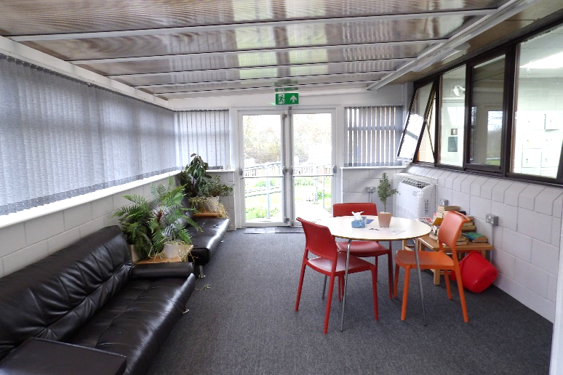
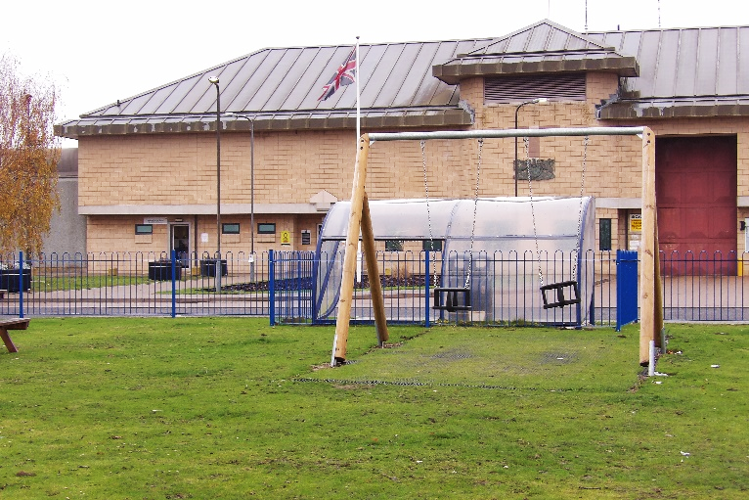
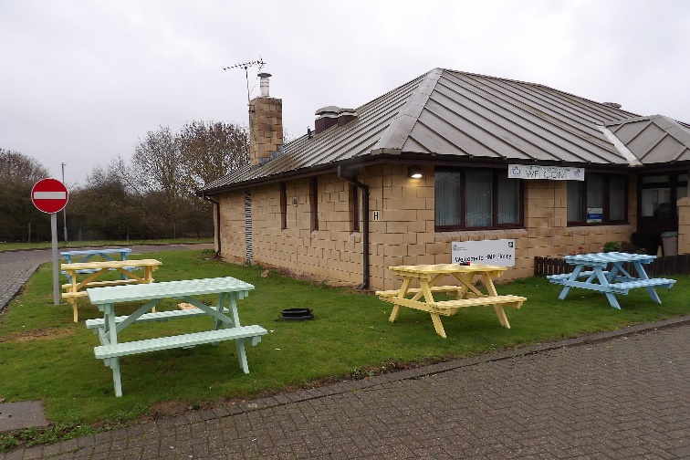

HMP Elmley visitor’s centre.
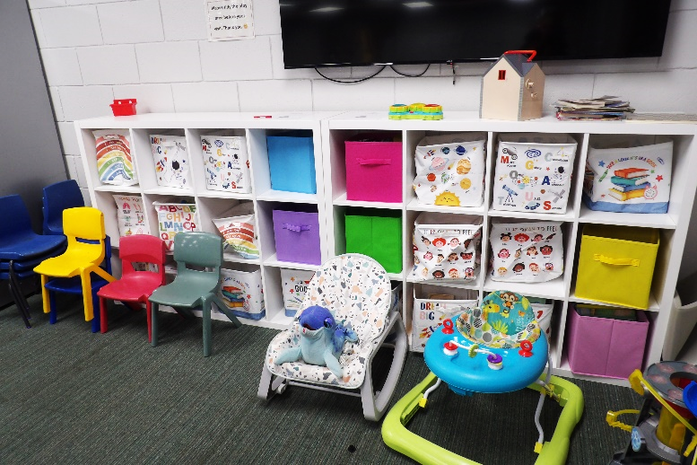
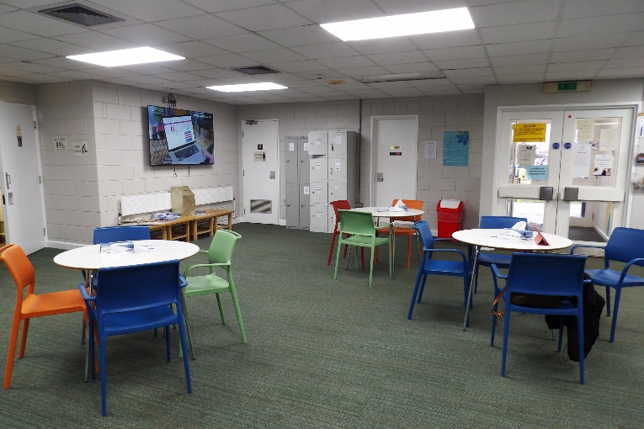

HMP Elmley visit’s Hall.
