
Family and Significant Others Strategy

Governing Governor Fiona Merrifield
January 2026

 | Page
Statement of Intent | 2
1.Families & Significant Other (FaSO) Staffing Structure | 3
2. Working in Partnership | 4
3. Performance & Measurement | 6
4. Staying Connected | 7-9
5. Notable Demographics | 9
6. Safeguarding | 9
7. Additional Information & Resources for FaSO’s | 9-10
8.Strategy Action Plan | 11

Statement of Intent

HMP & YOI Hindley will encourage prisoners to maintain and build positive ties with family and significant others (FaSO) to reduce reoffending and minimise inter-generational offending. We will work in partnership with other agencies to support prisoners and families and will ensure FaSO provision is considered across all delivery to improve resettlement outcomes.

The Head of Reducing Reoffending (HORR) is a senior leader within the prison and is tasked with leading on FaSO provision.

The Head of Operations manages the visits provision within the establishment and will support the HORR in ensuring FaSO delivery meets the needs of the population.

Partners of Prisons (POPs) is the contracted provider supporting FaSO provision.

We will commit to reinvest any profit made from the sale of refreshments in social visits to enhance the FaSO offer.

The above stakeholders will meet monthly to develop FaSO provision continuously. This will be progressed through consultation with Prisoners, Families and External Organisations.

1. Families & Significant Others Staffing Structure

The staffing structure ensures Families & Significant Others Provision is an operational priority at HMPYOI Hindley. The following structure outlines how provsion is delivered and managed. The Family Services Provider for Hindley is POPs.

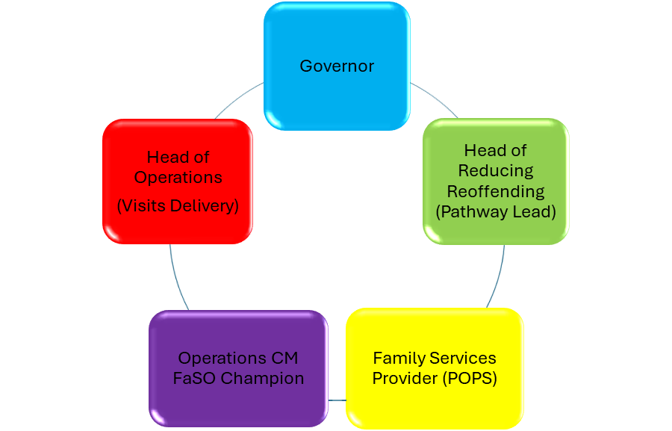

The role of the Family and Significant Other (FaSO) Lead is to function as strategic lead in supporting, developing, and promoting the value of positive relationships as a protective factor in the desistance of crime.

The lead will set out the strategic response to the Farmer “family offer” and the establishments general approach to family and significant other work.

The role of the Family and Significant Other (FaSO) Champion is to in supporting, developing, and promoting the value of positive relationships as a protective factor in the desistance of crime.

Assist the lead in setting out the strategic response to the Farmer “family offer” and the establishments general approach to family and significant other work.

Partners of Prisons (POPs) - We work in partnership with our contracted provider POPs who are committed to providing an integrated service for families and prisoners. Their staff host visitors in the visitor's centre/visits and are an integral part of the Hindley FaSO offer. We hold regular meetings to ensure we are working in unison.


2. Working in Partnership

All departments in the prison will be responsive to family support though some areas are more heavily involved:
Chaplaincy
Provide support to prisoners and families through pastoral support to prisoners (and families) and will support men through many life events (i.e., wellbeing, divorce, separation, child adoption, bereavement). The department is key in making Family Days a successful and routine offer, they accommodate “special visits” in exceptional circumstances, build father – child relations through delivery of courses and co-ordinate our Neurodiverse “Blue” visits offer to ensure suitable Prisoners and Family Members gain access.
Offender Management Unit
Help prisoners and families progress through their sentence by encouraging positive relationships that help rehabilitation and resettlement become a focal point. They will work towards supporting prisoners transfer nearer to home to access visits (either through permanent transfer or via accumulated visits). Prison Offender Managers will work with Community Offender Managers to support prisoners in preparation for release. They will identify men in need of support where they have no FaSO contact or where they may benefit from Chaplaincy parenting intervention.
Safety Team
A 24 hour safeguarding phone line (01942 663294) allows families to contact the prison if they have any concerns regarding a prisoner. The team will also field any concerns logged through the internet Safety Portal (HMP/YOI Hindley | Prisoners' Families Helpline). Both are checked daily for any information from families. We understand that supporting prisoners is a joint effort. Information provided by families is useful and acted upon. Calls and follow up actions are logged to give managerial oversight and assurance. This information is advertised in the Visitors centre and available through POPs.

In an emergency
Call 01942 663 100 if you think a prisoner is at immediate risk of harm. Ask for the Orderly Officer and explain that your concern is an emergency.

Keyworker
Hindley’s Key Work Model Keyworkers may contact FaSO, normally with the prisoner's permission, to improve communication, understanding and progression.

CGL (Change, Grow, Live)
Substance misuse is a concern. CGL provide a Recovery offer to prisoners and help safeguard the population against drugs. The service provides prisoners with support to access services, plan for release and look at the impact of their behaviour and substance misuse on family members. CGL workers can also provide some signposting to family support in the community and help prisoners to change and improve family relationships.
Partners of Prisoners (POPs)
Aims
- Improve family relationships: By offering support, advice, and tools to help families strengthen their bonds.
- Reduce stress and isolation: We help families feel more supported and less alone in their journey, providing both practical and emotional assistance.
- Facilitate successful reintegration: Preparing families for their loved one’s release, helping to ensure a smooth transition back into the community and reducing the likelihood of reoffending.

What they do:
- One-to-One Family Support.
- Social Visits.
- Family Days.
- Emotional Support.
- Information and Advice.
- Practical Support.
- Family Forums.
- Social Isolation.

Information on POPs can be found at https://www.partnersofprisoners.co.uk/who-partners-of-prisoners-are/ .
Other organisations we work in partnership with include Samaritans, Independent Monitoring Board (IMB), Greater Manchester Police and Social Services.

3. Performance and Measurement
We will measure how effective our family services are and use feedback constructively to improve service. Feedback will be gained through visits uptake, information provided on specific events, data scrutiny at FaSO and Family Service Contract Meetings and through His Majesties Prison Inspections. Key contributors of information leading to development will be:
Visits & FaSO Champion
The Operations Custodial Manager is the FaSO Champion and a key member of the FaSO Meeting. Their role is to maximise the family experience when entering the establishment and to ensure equal and courteous treatment for all visitors. He/she will endeavour to develop initiatives and support POPs in their contract delivery and be responsive to all survey, inspection and IMB feedback.
Visitor & Prisoner Survey
Two visitor & prisoner surveys are each carried out annually to ask visitors and prisoners for views on the visits service. Positives, Issues and themes are considered and developed through the FaSO Meeting.
Family Forums
A bi-annual Family Forum will allow family members to meet, raise concerns and offer feedback. We will also use these forums to improve understanding around the services on offer for prisoners within the prison. Heads of Functions will attend these forums to share information and respond to concerns.
Prison Council
Elected prisoner representatives from each wing meet monthly to discuss any concerns they have with all elements of life at Hindley. This often includes discussions around FaSO issues. Any concerns raised are logged on the action plan and through the SLT meetings are addressed and responded to. POPs are invited to the FaSO Meeting at least every 6 months so they can support and update the council.
Complaints/Suggestions Process
POPs have developed a complaints/suggestions form for visitors to complete at the Visitor’s Centre. This has been mirrored in the Visits Hall with a comments book for non-urgent issues and comments. Visitors are encouraged to speak to staff members with any issues or suggestions. Signage around how non-prisoners can make a complaint are displayed around the visits function.
4. Staying Connected
Social visits are the main way most prisoners will get access to their FaSO’s, a separate local Visits Policy provides all related information with essential information available on https://www.gov.uk/guidance/hindley-prison . Not all families can access the prison, for a variety of different reasons. Each prisoner is asked as part of the Induction process, by an experienced POM, about FaSO support. We will ensure we bridge any identified gaps created through a variety of different options:
PIN Phones

All cells are equipped with “in cell telephones” to enable prisoners to make outgoing calls to numbers that have been applied for and approved.

Prison Video Visits (like Facetime)

We offer a Video Visit offer to Families and prisoners. Priority for prisoners booking these calls is given to those not accessing visits. It requires the visitor to download an application to their phone, tablet or other internet enabled device, is free of charge and can be accessed at https://www.prisonvideo.com .

Letters

Convicted Prisoners are entitled to 1 x postage paid second class letter per week. Additional letters may be sent out at a prisoner’s expense. Incoming mail is processed and delivered on the date it is received into the prison.

Email a Prisoner

Email a prisoner is a service which allows you to email a prisoner for them to reply. This is a charged service costing £0.40 per message sent. Prisoner replies are free of charge. The service can be accessed at https://www.emailaprisoner.com.

Prison Voicemail
The service allows friends and family to contact the prison and leave a voicemail message for a prisoner who can then pick the message up using an individual voicemail pin number, this allows families to leave messages at a convenient time for prisoners without worrying about them missing a call – see Get your free 0808 number now - free calls from UK prisons to your mobile.

Blue Visits

One mid-week afternoon each month is dedicated to “blue visits”. Our Neurodiversity Manager and Chaplaincy Team identify men with neuro-diverse impairments that would preclude them from engaging in routine and noisy social visits sessions. The capacity of visits is greatly reduced for such events, lowering noise levels, and makes them accessible and more appropriate for respective individuals. The Chaplaincy Team will liaise directly with families to provide access to blue visits. Those visiting, are eligible to the same considerations for access to blue visits. In such instances prisoners should apply directly to the Chaplaincy Team for consideration and authorisation to access the visits.

Family Days

These are significantly different from normal Social Visits which take place daily. Family Visits offer a more relaxed environment for both prisoners and visitors. The Family Days run to a theme such as Sports Day, Christmas, and many more. During all Family Days there are activities on offer such as:
- Group activities
- Arts & Crafts
- Competitions
- Games
- Guest Appearances from outside partner agencies.
- Celebration events

Family Days are scheduled monthly and are advertised to both Prisoners and Families. Family Days are available to all prisoners irrespective of their Incentives Earned Privileges level and must be applied for by the prisoner in accordance with each Family Day criteria.
Prisoner Visitors
Prisoners who do not have any FaSO’s or any FaSO’s who are unable to visit can request to have a volunteer Prison Visitor who will visit and provide support through phone calls or as a pen pal. This service is offered by the Chaplaincy Department (for more information see https://www.naopv.com/).
We monitor which of our prisoners do not have visits and ensure support is made available for them through POPs engagement and non-visits events. These Non-Visits events have been developed to offer a monthly session for those identified as not receiving any FaSO contact. These sessions include activities, forums an opportunity for support and shared experience.

Assisted Prison Visiting Unit (APVU)
For visitors who are simply unable to afford visiting the prison they can claim back up to two visits a month travel costs through APVU. Terms and conditions apply. Information is available in the Visitors Centre or by visiting https://www.gov.uk/help-with-prison-visits

5. Notable Demographics
Young Adults (18-25)
Approx 33% of our men are Young Adults. We know that men in this age group have different needs from older adults. We have a separate Young Adults Strategy to tailor our offer accordingly in respect of this cohort of prisoners.
In respect of FaSO provision, we will commit to hold one dedicated Young Adults Family Visit annually. This will feature activities which the young adults have told us they want to do with their families. Other events will be linked in with things such as the Twinning Project and the Duke Of Edinburgh Scheme
Care Experienced
Many prisoners in our care have care experience. We endeavour to have a clear understanding of who these prisoners are at any one time. Prison Offender Managers and POPs will explore what FaSO is available and beneficial for these men – and will engage Social Service Key Workers as appropriate. OMU have a named Care Leaver Champion who is a central point of contact and link with other establishments to share good practice, progress initiatives and understand need through Care Leavers Forum.

6. Safeguarding
We will ensure the safety of all FaSO’s through robust public protection and safeguarding measures. All operational staff within the Operations/Visits staff group will be trained in Safeguarding and understand how to intervene and escalate any identified concerns. Safeguarding measures are described in more detail in both local Visits and Safeguarding Policies.

7. Additional Information & Resources for FaSO’s

- AFFECT – AFFECT provides services for the families of serious prisoners and offers support groups to families in the south of England. www.affect.org.uk

- Assisted Prison Visits Unit (APVU) – help with the cost of prison visits https://www.gov.uk/help-with-prison-visits
- Family Lives www.familylives.org.uk– Family lives, works for the benefit of prisoners' and prisoners' families by representing the views of families and those who work with them.

- Families Outside www.familiesoutside.org.uk 0800 254 0088 The free helpline is an independent support service for families and friends affected by imprisonment. They aim to help with any questions or concerns you may have.

- Email a Prisoner - www.emailaprisoner.com

- Inside Time – https://insidetime.org– this website gives visiting and other advice

- NICCO - National Information Centre on Children of Prisoners is a one-stop information and advice service to support all professionals (working with children and families of prisoners) and all families of prisoners, bringing together useful information in one place. www.nicco.org.uk

- Pact (Prison Advice and Care Trust) – www.prisonadvice.org.uk A national charity that provides support to prisoners, people with convictions and their families through a range of services, including a national helpline, digital information services, casework, play, group work, mentoring and befriending programmes. (Pact Prisoners’ Families Helpline: 0808 808 3444)

- POPS - www.partnersofprisoners.co.uk They aim to provide a variety of services to support anyone who has a link with someone in prison, prisoners and other agencies. POPS provides assistance to these groups for the purpose of enabling them to cope with the stress of arrest, sentence, imprisonment, and release.

- Prisoners’ Family Voices is a web-based community which gives family members the opportunity to talk to each other. http://prisonersfamiliesvoices.blogspot.com

- Prison voicemail – www.prisonvoicemail.com

- Prisoners’ Families Helpline 0808 808 2003 info@prisonersfamilieshelpline.org.uk

8. Strategy Action Plan

Strategy Action Plan Checklist
6 Monthly Survey of Visitors is conducted
6 Monthly Survey of Prisoners is conducted
Annual Family Forum completed
Monthly Family Visits Schedule Published for each calendar year
NICCO & Gov UK Website accurate
Monthly Visits Availability Check with Visits Booking
Develop understanding and interventions for men with no FaSO support

